Collaborative Information Behavior of Virtual Math Teams in a Multimodal Online Environment

Murat Perit Çakır
i-School @ Drexel University, 3141 Chestnut St., Philadelphia PA 19104, mpc48@drexel.edu

Gerry Stahl
i-School @ Drexel University, 3141 Chestnut St., Philadelphia PA 19104, gerry.stahl@drexel.edu

Collaborative teamwork has become a central aspect of work practice in today’s knowledge-based industry due to its increasingly recognized impact on fostering innovation and organizational development (Nosek, 2004; Chi & Holsapple, 2005). The growing prominence of collaborative work has led to the emergence of a new research area within Information Science (IS) called Collaborative Information Behavior (CIB), which investigates the role of collaboration on information seeking activities of small groups (Reddy & Jansen, 2008). CIB has chiefly emerged as a response to the limitations of traditional models in IS that solely focus on the information behavior of individuals (Talja & Hansen, 2006). In particular, such individually oriented models fall short in addressing the interactional complexities involved with collaborative scenarios where a small team of users collectively seek, share, and make sense of information (ibid.).

In the field of Instructional Technology a similar shift of analytical focus from individual learners to groups has led to the growth of Computer-Supported Collaborative Learning (CSCL) (Stahl, Koschmann & Suthers, 2006; Koschmann, 1996). A central issue in the theory of collaborative learning is how students can solve problems, build knowledge, accomplish educational tasks and achieve other cognitive accomplishments together. How do they share ideas and talk about the same things? How do they know that they are talking about, thinking about, understanding and working on things in the same way? Within CSCL this has been referred to as the problem of the “attempt to construct and maintain a shared conception of a problem” (Roschelle & Teasley, 1995), “building common ground” (Clark & Brennan, 1991) or “the practices of meaning making” (Koschmann, 2002). We have been interested in the joint organization of knowledge building interactions in online environments for some time: (Stahl, 2006) documents a decade of background to the research reported here, chapter 10 (written in 2001) argued the need for a new approach and chapter 17 (written in 2002) proposed our current project that includes this short paper. During the past six years, we have been studying how students in a synchronous collaborative online environment organize their interaction so as to achieve shared cognitive accomplishments in the domain of school mathematics.

Information behavior studies conducted in the K-12 school setting mainly focus on the information needs of individual students and the impact of information resources on their learning. Information creation is a relatively unexplored dimension in this line of work that refers to the processes where students are socialized (i.e., learn to act in accordance with the normative organization of the classroom setting) to create and use information resources as part of their school work (Trace, 2007). Information creation is particularly important in an educational setting since its products serve as the main resource for the assessment of students’ progress. The theory of knowledge building in CSCL closely resonates with this emerging concept in IS, which characterizes learning as a product of a collective inquiry process where pieces of information collected through various resources are actively refined into novel ideas through discourse (Scardamalia & Bereiter, 1996).

Knowledge-building discourse in CSCL has traditionally been supported primarily with asynchronous, web-based technologies (Scardamalia & Bereiter, 2006). Within appropriate educational cultures, this can be effective for long-term development of ideas by learning communities. However, in small groups and in many classrooms, asynchronous media encourage sharing of individual opinions more than co-construction of progressive trains of thought. The mere availability of hyper-linked resources provided by students and/or teachers does not necessarily translate to learning gains (Dillon, 2000). We have found that synchronous interaction can more effectively promote what we term “group cognition”—the accomplishment of “higher order” cognitive tasks through the coordination of contributions by individuals within the discourse of a small group.
In CSCL settings, interaction is mediated by a computer environment. Students working in such a setting must enact or invent ways of coordinating their understandings by means of the technological affordances that they find at hand. The development and deployment of these methods is not usually an explicit, rational process that is easily articulated by either the participants or analysts. It takes place tacitly, unnoticed, taken-for-granted. In order to make it more visible to us as analysts, we have developed an environment called Virtual Math Teams (VMT) Chat that makes the coordination of interaction more salient and captures a complete record of the group interaction for detailed analysis (See Figure 1 below). In trying to support online math problem solving by small groups, we have found it important to provide media for both linguistic and graphical expression. This resulted in what is known within CSCL as a dual-interaction space. In our environment, students have to coordinate text chat postings with whiteboard drawings. A detailed and rigorous analysis of how they do this reveals as well their more general methods of social organization.

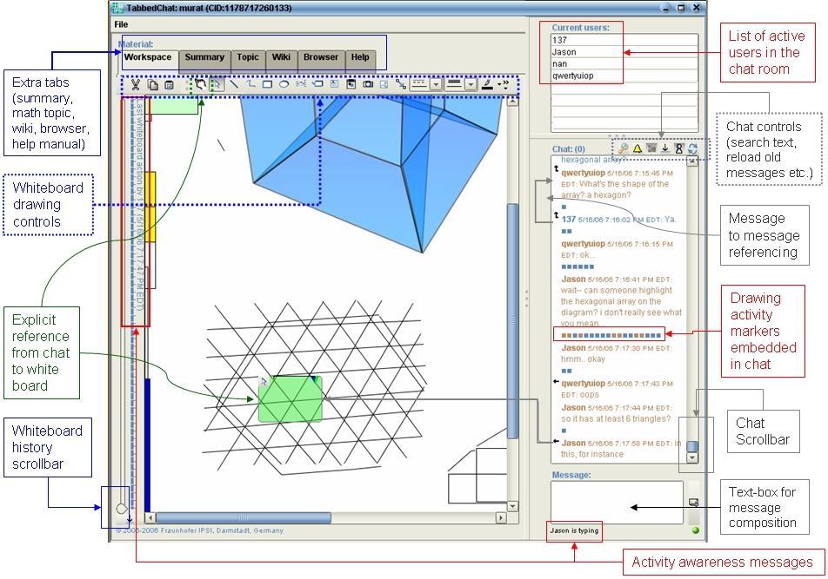
Figure 1: The VMT Online Environment

We conducted numerous problem-solving sessions with upper-middle school and high-school students to investigate their collective information behavior online. Data collection was done in collaboration with the Math Forum. The Math Forum is a popular online service that offers online mentoring and a vast digital library of math mainly targeting the K-12 level. During these sessions teams of 3-5 students from different schools in the US and Singapore worked on non-routine, open-ended math problems. Each session lasted about an hour. A Math Forum member was present in the chat room as a moderator during all sessions in case teams may need help with technical difficulties; moderators did not participate in the problem-solving discussion.

In an effort to investigate the joint organization of interactions across the dual-interaction spaces of the VMT environment, we consider the small group as the unit of analysis (Stahl, 2006a) and appropriate methods of Ethnomethodology (EM) and Conversation Analysis (CA) to conduct sequential analysis of recorded group interactions at a micro-level (Sacks, 1992; ten Have, 1999; Psathas, 1995). The goal of this line of micro-analytic work is to discover the commonsense understandings and procedures group members use to organize their conduct in particular interactional settings (Coulon, 1995). Commonsense understandings and procedures are subjected to analytical scrutiny because they “enable actors to recognize and act on their real world circumstances, grasp the intentions and motivations of others, and achieve mutual understandings” (Goodwin & Heritage, 1990 p. 285). Members’ shared competencies in organizing their conduct not only allow them to produce their own actions, but also to interpret the actions of others (Garfinkel & Sacks, 1970). Since members enact these understandings/procedures in their situated actions, researchers can discover them through detailed analysis of members’ sequentially organized conduct (Schegloff & Sacks, 1973).

Our analysis has revealed important insights regarding the affordances of systems with dual interaction spaces.
- First, we observed that the whiteboard can make visible to everyone the animated evolution of a geometric construction, displaying the visual reasoning process manifested in drawing actions.
- Second, whiteboard and chat contents differ in terms of mutability of their contents, due to the object-oriented design of the whiteboard that allows modification and annotation of past contributions.
- Third, the media differ in terms of the persistence of their contents: whiteboard objects remain in the shared visual field until they are removed, whereas chat content gradually scrolls off as new postings are produced.
- Although contents of both spaces are persistently available for reference, due to linear progression of the chat window chat postings are likely to refer to visually (and hence temporally) proximal messages.
- Finally, the whiteboard objects index a horizon of past and future activities as they serve as an interactional resource through the course of recognizably distinct but related episodes of chat discussion.

Our analysis has also revealed methods for the organization of collaborative work, through which group members co-construct mathematical meanings sedimented in semiotic objects distributed across the dual interaction spaces of the VMT environment. We observed that bringing relevant math artifacts referenced by indexical terms such as “hexagonal array” to other members’ attention often requires a coordinated sequence of actions across both interaction spaces. Participants use explicit and verbal references to guide each other about how a new contribution should be read in relation to prior contents. Indexical terms stated in chat referring to the witnessed production of shared objects are instrumental in the reification of those terms as meaningful mathematical objects for the participants. Verbal references to co-constructed objects are often used as a resource to index complicated mathematical concepts in the process of co-constructing new ones. Finally, different representational affordances of the dual interaction spaces allow groups to develop multiple realizations of the math artifacts to which they are oriented. Shared graphical inscriptions and chat postings are used together as semiotic resources in mutually elaborating ways. Methods of coordinating group interaction across the media spaces also interrelate the mathematical significances of the multiple realizations. In math education theory this kind of mathematical engagement is considered as an important indicator of deep learning of corresponding mathematical concepts (Sfard, 2008).

Overall, we observed that actions performed in both interaction spaces constitute an evolving historical context for the joint work of the group (Goodwin & Duranti, 1992). What gets done now informs the relevant actions to be performed next, and what was done previously can be reproduced/modified depending on the circumstances of the ongoing activity. As the interaction unfolds sequentially, the sense of previously posted whiteboard objects and chat statements may become evident and/or modified. In other words, we have seen the establishment of an indexical ground of deictic references (Hanks, 1992) co-constructed by the group members as an underlying support for the creation and maintenance of their shared problem space. We have seen that nexus of references created interactionally as group members propose, question, repair, respond, illustrate, make visible, supply symbols, name, etc. In the VMT dual-media environment, the differential persistence, visibility, and mutability of the media is consequential for the interaction. Group members develop methods of coordinating chat and drawing activities to combine visual and conceptual reasoning by the group and to co-construct and maintain an evolving shared indexical ground of their discourse.

Although the focus of our research has been on the collaborative learning of mathematics in an online environment, we believe the interactional processes highlighted in our case studies are highly relevant for understanding the interactional organization of CIB online. In the broader context of CIB, small groups of users actively engage with each other and with information systems to coordinate and address their joint information needs. The information accessed through systems and past experiences of team members altogether serve as resources for the team. Our case studies investigate the interactional mechanisms by which teams weave these resources into knowledge artifacts that incrementally address their collective information need. In particular, our work highlights the importance of sequentiality and indexicality in the achievement and maintenance of a shared understanding of a joint information need. Hence, providing properly designed software support for teams to share and jointly manipulate information resources along these empirical insights are of paramount importance in effectively supporting CIB online.

References
Chi, L., & Holsapple, C. W. (2005). Understanding computer-mediated interorganizational collaboration: a model and framework. Journal of Knowledge Management, 9(1), 53-75.
Clark, H. H., & Brennan, S. (1991). Grounding in communication. In L. B. Resnick, J. M. Levine & S. D. Teasley (Eds.), Perspectives on Socially Shared Cognition (pp. 127-149). Washington DC: American Psychological Association.
Coulon, A. (1995). Ethnomethodology. Thousand Oaks, CA: Sage.
Dillon, A. (2000). Designing a better learning environment with the Web: problems and prospects. CyberPsychology and Behavior, 3(1), 97-102.
Garfinkel, H., & Sacks, H. (1970). On formal structures of practical actions. In J. Mckinney & E. Tirvakian (Eds.), Theoretical sociology: Perspectives and developments (pp. 337-366). New York, NY.
Goodwin, C., & Duranti, A. (1992). Rethinking context: An introduction. In C. Goodwin & A. Duranti (Eds.), Rethinking context: Language as an interactive phenomenon (pp. 1-43). Cambridge, UK: Cambridge University Press.
Goodwin, C., & Heritage, J. (1990). Conversation Analysis. Annual Review of Anthropology, 19, 283-307.
Hanks, W. F. (1992). The indexical ground of deictic reference. In A. Duranti & C. Goodwin (Eds.), Rethinking context: Language as an interactive phenomenon (pp. 43-76). Cambride, UK: Cambridge University Press.
Koschmann, T. (2002). Dewey's contribution to the foundations of CSCL research. In G. Stahl (Ed.), Computer Support for Collaborative Learning: Foundations for a CSCL Community: Proceedings of CSCL 2002 (pp. 17-22). Boulder, CO: Lawrence Erlbaum Associates.
Nosek, J. T. (2004). Group cognition as a basis for supporting group knowledge creation and sharing. Journal of Knowledge Management, 8(4), 54-64.
Psathas, G. (1995). Conversation Analysis: The Study of Talk-in-Interaction. Thousand Oaks, CA: Sage Publications.
Reddy, M. C., & Jansen, B. J. (2008). A model for understanding collaborative information behavior in context: A study of two healthcare teams. Information Processing and Management, 44, 256-273.
Roschelle, J., & Teasley, S. (1995). The construction of shared knowledge in collaborative problem solving. In C. O'Malley (Ed.), Computer-supported collaborative learning (pp. 69-197). Berlin, Germany: Springer-Verlag.
Sacks, H. (1962/1995). Lectures on Conversation. Oxford, UK: Blackwell.
Scardamalia, M., & Bereiter, C. (1996). Computer Support for Knowledge-Building Communities. In T. Koschmann (Ed.), CSCL: Theory and Practice (pp. 249-268). Mahwah, NJ: Lawrence Erlbaum Associates.
Scardamalia, M., & Bereiter, C. (2006). Knowledge Building: Theory, Pedagogy, and Technology. In R. K. Sawyer (Ed.), The Cambridge Handbook of the Learning Sciences (pp. 97-118). NY: Cambridge University Press.
Schegloff, E. A., & Sacks, H. (1973). Opening up closings. Semiotica, 7, 289-327.
Sfard, A. (2008). Thinking as communicating: Human development, the growth of discourses, and mathematizing. New York, NY: Cambridge University Press.
Stahl, G. (2006). Group Cognition: Computer Support for Building Collaborative Knowledge. Cambridge, MA: MIT Press.
Stahl, G., Koschmann, T., & Suthers, D. (2006). Computer-Supported Collaborative Learning. In R. K. Sawyer (Ed.), The Cambridge Handbook of the Learning Sciences (pp. 409-426). New York: Cambridge University Press.
Talja, S., & Hansen, P. (2006). Information Sharing. In A. Spink & C. Cole (Eds.), New Directions in Human Information Behavior (pp. 113-134). Dordrecht, Netherlands: Springer.
Ten Have, P. (1999). Doing conversation analysis, A practical guide. Thousand Oaks, CA: Sage Publications.
Trace, C. B. (2007). Information creation and the notion of membership. Journal of Documentation, 63(1), 142-163.

The CA methodology achieves a sense of validity by (1) subjecting analysis to intersubjective agreement among researchers through data sessions, and (2) providing unreduced access to data to allow external scrutiny of analytical claims (ten Have, 1999). Nevertheless, we provide an overall summary of our findings without being able to demonstrate any empirical analysis due to space considerations. For more information please refer to our list of publications at http://vmt.mathforum.org/vmt/researchers/publications.html

