Gerry Stahl’s assembled texts volume #21

Dynamic Geometry Game for Pods

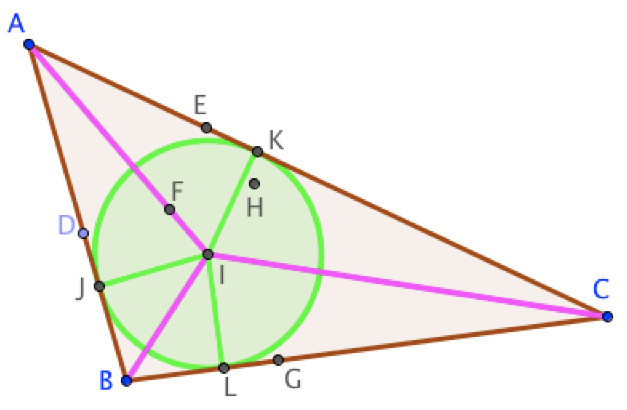

Gerry Stahl

Gerry Stahl's Assembled Texts

- Marx and Heidegger
- Tacit and Explicit Understanding in Computer Support
- Group Cognition: Computer Support for Building Collaborative Knowledge
- Studying Virtual Math Teams
- Translating Euclid: Designing a Human-Centered Mathematics.
- Constructing Dynamic Triangles Together: The Development of Mathematical Group Cognition
- Essays in Social Philosophy
- Essays in Personalizable Software
- Essays in Computer-Supported Collaborative Learning
- Essays in Group-Cognitive Science
- Essays in Philosophy of Group Cognition
- Essays in Online Mathematics Interaction
- Essays in Collaborative Dynamic Geometry
- Adventures in Dynamic Geometry
- Global Introduction to CSCL
- Editorial Introductions to ijCSCL
- Proposals for Research
- Overview and Autobiographical Essays
- Theoretical Investigations
- Works of 3-D Form
- Dynamic Geometry Game for Pods

Gerry Stahl’s assembled texts volume #21

Dynamic Geometry
Game for Pods

Gerry Stahl

2020, 2021

Gerry Stahl
Gerry@GerryStahl.net
www.GerryStahl.net

Copyright © 2020, 2022 by Gerry Stahl
Published by Gerry Stahl at Lulu.com
Printed in the USA
ISBN: 978-1-71663-828-2 (eBook)
ISBN: 978-1-71663-803-9 (paperback)

Welcome
These days, much student learning takes place in small “pods” of students working together. Often, they interact and communicate online. In addition, students engage in home-schooling, drawing upon online resources and media.
Online and pod-based education opens new opportunities for highly motivating and effective approaches. However, success requires innovative and well-designed curriculum. The present “Dynamic Geometry Game for Pods” translates the learning of traditional Euclidean geometry into an engaging, stimulating and collaborative experience for online pods of students or for individual home-schooled students.
Dynamic geometry is a recent transformation of classic geometry into an online app, which allows one to explore geometric figures by dragging them around the computer screen. Students can construct their own figures and receive immediate automated feedback about the results. This can provide a lively, hands-on experience of geometry.
A free computer app, GeoGebra, is available at: www.geogebra.com. GeoGebra now includes a Class mode that is ideal for small pods of students working together under a teacher’s supervision. GeoGebra student apps and teacher Class dashboard can be shared in a Zoom session if desired. The Dynamic Geometry Pod Game can be opened at: https://www.geogebra.org/m/vhuepxvq#material/swj6vqbp. The game can be played immediately then.
If you would like to print out a copy of the game – perhaps to take notes in – this pdf version is available at: http://gerrystahl.net/elibrary/game/game.pdf.
Since the beginning of Western civilization 2,500 years ago, geometry has trained students in rigorous thinking. Perhaps dynamic geometry can help the next generation enhance their understanding of today’s complex world.
At the end of this volume is an academic article that discusses how this game can be a model of curriculum for “blended learning,” which combines teacher-led classroom instruction and student-centered collaborative learning. It was published as: Stahl, G. (2021). Redesigning mathematical curriculum for blended learning. Education Sciences. 11(165), pages 1-12. Web: https://www.mdpi.com/2227-7102/11/4/165.

Contents
Welcome 5
Contents 6
Intro for Adventurous Students 10
Intro for Parents and Teachers 12
Game Part A 14
LEVEL 1. BEGINNER LEVEL 14
Challenge 1: Play House 15
Challenge 2: Dynamic Stick Figures 16
Challenge 3: Play around with Points, Lines and Circles 17
LEVEL 2: CONSTRUCTION LEVEL 18
Challenge 4: Play by Dragging Connections 18
Challenge 5: Play with Hidden Objects 19
Challenge 6. Construct Polygons in Different Ways 20
LEVEL 3: TRIANGLE LEVEL 21
Challenge 7: Construct an Equilateral Triangle 21
Challenge 8: Find Dynamic Triangles 22
LEVEL 4: CIRCLE LEVEL 23
Challenge 9: Construct the Midpoint 23
Challenge 10: Construct a Perpendicular Line 24
Challenge 11: Construct a Parallel Line 25
Game Part B 27
LEVEL 5: DEPENDENCY LEVEL 27
Challenge 12: Triangles with Dependencies 28
Challenge 13: An Isosceles Triangle 29
Challenge 14: A Right Triangle 30
Challenge 15: An Isosceles-Right Triangle 31
LEVEL 6. COMPASS LEVEL 31
Challenge 16: Copy a Length 32
Challenge 17: Use the Compass Tool 33
Challenge 18: Make Dependent Segments 34
Challenge 19: Add Segment Lengths 35
Challenge 20: Copy vs. Construct a Congruent Triangle 36
Challenge 21: Construct a Congruent Angle 37
Game Part C 39
LEVEL 7: CONGRUENCE LEVEL 39
Challenge 22: Combinations of Sides and Angles of Triangles 40
Challenge 23: Side-Side-Side (SSS) 41
Challenge 24: Side-Angle-Side (SAS) 42
Challenge 25: Angle-Side-Angle (ASA) 43
Challenge 26: Side-Side-Angle (SSA) 44
LEVEL 8. INSCRIBED POLYGON LEVEL 45
Challenge 27: The Inscribed Triangles Challenge Problem 45
Challenge 28: Inscribed Squares 46
Challenge 29: Prove Inscribed Triangles 47
Game Part D 49
LEVEL 9: TRANFORMATION LEVEL 49
Challenge 30: Translate by a Vector 50
Challenge 31: Reflect About a Line 51
Challenge 32: Rotate Around a Point 52
Challenge 33: Combine Transformations 53
Challenge 34: Create Dynamic Patterns 54
LEVEL 10. QUADRILATERAL LEVEL 54
Challenge 35: Construct Quadrilaterals with Constraints 55
Challenge 36: Construct a Rhombus 56
Challenge 37: Quadrilateral Areas 57
Challenge 38: Build a Hierarchy of Quadrilaterals 58
Game Part E 60
LEVEL 11: ADVANCED GEOMETER LEVEL 60
Challenge 39: The Centroid of a Triangle 61
Challenge 40: The Circumcenter of a Triangle 62
Challenge 41: The Orthocenter of a Triangle 63
Challenge 42: The Incenter of a Triangle 64
Challenge 43: The Euler Segment of a Triangle 65
Challenge 44: The Nine-Point Circle of a Triangle 66
LEVEL 12: PROBLEM SOLVER LEVEL 67
Challenge 45: Treasure Hunt 67
Challenge 46: Square and Circle 68
Challenge 47: Cross an Angle 69
LEVEL 13: EXPERT LEVEL 69
Challenge 48: How Many Ways Can You Invent? 70
Challenge 49: Dependencies in the World 71
Challenge 50: Into the Future 72
Extra Bonus Dynamic Geometry 73
A Special Challenge 73
Visualizing the World’s Oldest Theorem 74
Proof of Special Challenge 84
Proof Involving the Incenter of a Triangle 84
Your own Custom Geometry 91
Transforming a Factory 92
Navigating Taxicab Geometry 97
Redesigning Mathematical Curriculum for Blended Learning 102
Introduction: Student Pods during the Pandemic 102
Designing for Virtual Math Teams 104
Redesigning for Pandemic Pods with GeoGebra Classes 106
Findings from VMT Trials 110
Supporting Group Practices in Blended Learning 111
Broadening the Model for Blended Learning 116
References 118
Notes 122

Intro for Adventurous Students
The Dynamic Geometry Game for Pods is a series of Challenges for your pod to construct interesting and fun geometric figures. Many of the figures will have hidden features and your pod will learn how to design them. So put together your Pod with three, four, five or six people from anywhere in the world who want to play the game together online.
The Game consists of several levels of play, each with a set of Challenges to do together online. The Challenges in the beginning levels do not require any previous knowledge about geometry or skill in working together. Playing the Challenges in the order they are given will prepare you with everything you need to know for the more advanced levels. Be creative and have fun. See if you can invent new ways to do the Challenges.
Each Challenge has questions to think about and answer. These will help you to make sense of the Challenges and your solutions. Your responses to the questions will help your teammates in your pod to understand what you discovered about the Challenge and to know what you would like help understanding. Be sure to answer the questions and to read the answers from the rest of your pod. Try each Challenge at your level until everyone in your pod understands how to meet the Challenges. Then move on to the next level. Take your time until everyone has mastered the level. Then agree as a team to go to the next level. Most levels assume that everyone has mastered the previous level. The levels become harder and harder – see how far your pod can go.
Geometry has always been about constructing dependencies into geometric figures and discovering relationships that are therefore necessarily true and provable. Dynamic geometry (like GeoGebra) makes the construction of dependencies clear. The game Challenges at each level will help you to think about geometry this way and to design constructions with the necessary dependencies. The sequence of levels is designed to give you the knowledge and skills you need to think about dynamic-geometric dependencies and to construct figures with them.
Your construction pod can accomplish more than any one of you could on your own. You can discuss what you notice and wonder about the dynamic figures. Playing as part of a team will prevent you from becoming stuck. If you do not understand a geometry word or a Challenge description, someone else in the pod may have a suggestion. If you cannot figure out the next step in a problem or a construction, discuss it with your teammates. Decide how to proceed together. Enjoy playing, exploring, discussing and constructing!

Intro for Parents and Teachers
The Dynamic Geometry Game for Pods consists of 50 Challenges that introduce the player to basic ideas of dynamic geometry as implemented in GeoGebra and teach the most important software functions. The Challenges encourage thinking about geometric dependencies among points, lines, circles and polygons.
The hope is that players will experience the excitement of mathematical discoveries and explore ways of deeply understanding and discussing geometry. The 50 Challenges build step-by-step from doodling to major theorems of basic geometry. They provide hands-on involvement in problem solving and mathematical reflection. The sequence roughly follows Euclid and the US Common Core for geometry.
The Challenges were originally designed for use in the Virtual Math Teams research project, in which small groups of middle-school students collaborated online, sharing a GeoGebra construction and a text-chat tab. The group of students worked together with no direct supervision, spending about an hour collaborating on each Challenge.
In the current Game for Pods, the Challenges have been modified for use with the GeoGebra “Class” function, optionally within Zoom sessions. The new Challenges can be worked on by individual students, with a teacher observing a dashboard of a Class of students progressing through the Challenges.
The Coronavirus has made it common for students to learn in online pods of about 5 students, rather than in traditional classrooms of about 30 students. This opens the opportunity for a more collaborative online learning experience. Although the GeoGebra Class mechanism does not allow multiple students to share a joint construction, they can work in parallel and discuss their work as they do it. The Class dashboard can be made available to all the students. If the work takes place in a face-to-face setting or in a Zoom session, the students can talk or chat with each other, as well as typing answers to the questions for each of the Challenges and seeing what each other writes.
The Construction Pod Game can also be used for an individual student in home schooling. Ideally, the student would find several other students (either acquaintances or online peers) to form a pod and collaborate. Although it is structured as a game, the goal should not be to compete, but to advance together as a united pod. An individual student can be motivated by the game structure.
Teachers who want to use the Game with their students should first make copies for themselves. Then they can modify their copies however they want, especially editing the text of the Challenges or the associated questions to suit their teaching style, curricular goals or student characteristics. They can save their copy, publish it and press the “Create Class” button. Then they can invite a pod of students to the Class, both to work on the Challenges and to view the dashboard. The Class can be embedded in a Zoom meeting and the meeting can be recorded by the teacher for review.
Hopefully the students can collaborate among themselves with little or no teacher intervention during Game sessions. Students should be self-motivated to work through the levels of increasing Challenges. The GeoGebra software provides extensive feedback about successful constructions, especially if students use the drag test. Pod mates can help each other in many ways.
The teacher’s role can primarily be to integrate the sequence of Challenges with complementary sessions of teacher-led classroom discussion (both introductory presentations before Challenges and discussions of results afterward) and of individual student work (such as readings and homework). There can also be assignments such as reporting on Pythagoras, Thales, Euclid or Euler. The Construction Pod Game is divided into 5 Parts, each containing an average of 10 Challenges. The GeoGebra resources for the 5 Parts are available at:
Part A – https://www.geogebra.org/m/swj6vqbp
Part B – https://www.geogebra.org/m/dnammypy
Part C – https://www.geogebra.org/m/p7tx9vfp
Part D – https://www.geogebra.org/m/vggypcdu
Part E – https://www.geogebra.org/m/qhwajdzx
Please let me know if you have any questions or to report on your experiences: Gerry Stahl – Gerry@GerryStahl.net -- August 2020

Game Part A

LEVEL 1. BEGINNER LEVEL
Here is where you and your pod start to play with points, lines and circles.

Challenge 1: Play House

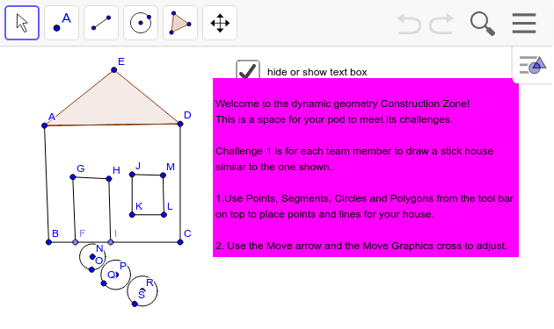

Questions. Please enter your answer to each question and read the answers of your pod mates.
How can you tell if a new point is placed on a line that is already there?
Dragging a point with the arrow tool is called the DRAG TEST in GeoGebra. It is a very important way to make sure that you constructed what you thought you were constructing – to be sure that things are connected properly. Always drag points you create to check them.
If you want to construct a line segment, is it better to place the two end-points first and then make the segment go from one to the other, or should you just place the line and let it create its own end-points?
If you want to create a circle, should you first create a point for its center and a point on its circumference, or should you just create the circle and let it create its own defining points?

Type your answer here…

Challenge 2: Dynamic Stick Figures
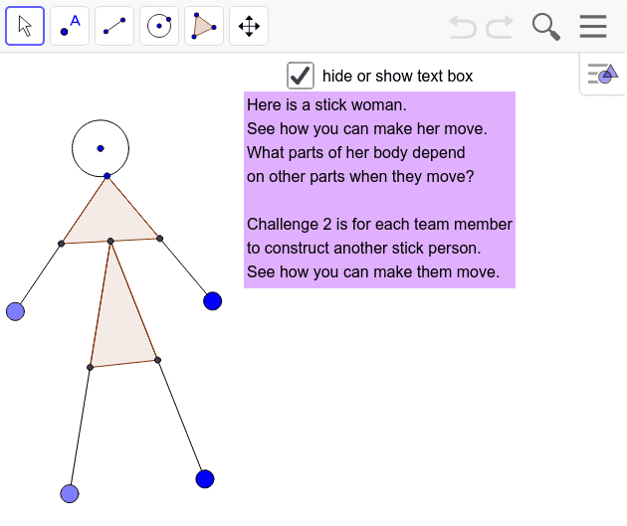

Questions.
Which points in the stick woman can move independently?
Which points move the whole woman? Which points move parts of the woman?
Why do some points move independently and others always move other points and lines?
Can you tell what order the woman was created in? What was the first point, etc.?
Can you create a stick woman that moves differently? Use the DRAG TEST to make sure your stick figure is working the way you want it to.

Type your answer here…

Challenge 3: Play around with Points, Lines and Circles
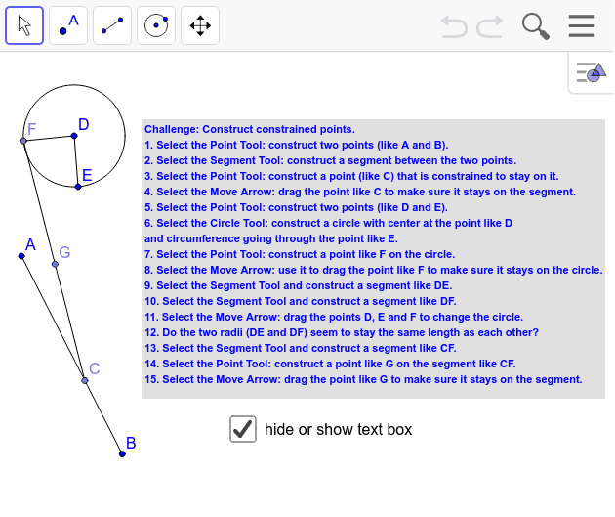

Questions.
How can you make a new point "stick" to an existing line segment?
Can that point go off the ends of the line segment?
How can you test to make sure that a point will always stay on a line segment?
How can you test to make sure that one line segment always starts on another line segment?
How can you test that a circle always has its center along a certain line segment?
In the original construction, which points would you have to drag to test that end F of line segment CF always stays on the circumference of circle DE –no matter how any other points in the construction are dynamically moved?

Type your answer here…

LEVEL 2: CONSTRUCTION LEVEL
At this level, you will play with geometric figures.

Challenge 4: Play by Dragging Connections
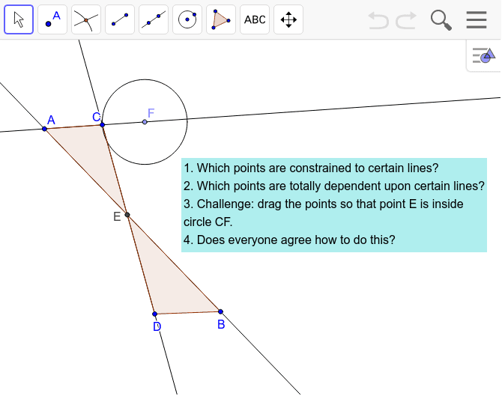

Questions.
What does each point in this construction control?
Are there any points that cannot be dragged (except by dragging a different point)? Do they have different colors?
What sequence of construction steps could have been used to build this?

Type your answer here…

Challenge 5: Play with Hidden Objects
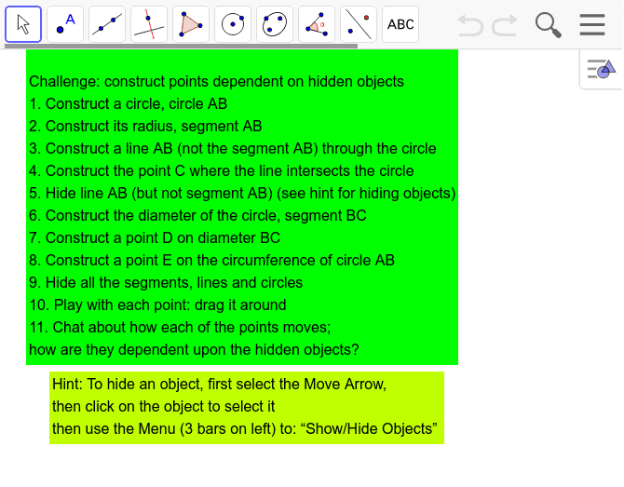

Questions.
What is the difference between a Line and a Line Segment?
What is the difference between a circle radius, a circle diameter and a circle circumference?
Which steps did you have trouble doing?
What is the difference between hiding an object and deleting that object?
Which points are dependent on which other objects, even when those objects are hidden?

Type your answer here…

Challenge 6. Construct Polygons in Different Ways
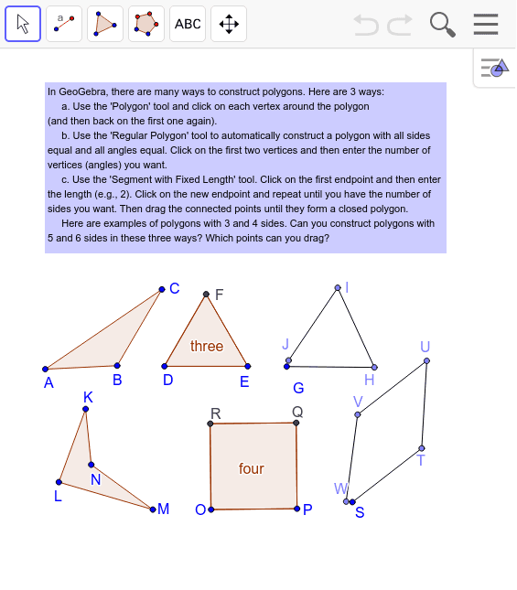

Questions.
What are polygons with 3, 4, 5 and 6 sides called?
What differences do you notice about the polygons constructed in these three different ways?
Drag all the points around. What stays the same? What does this make you wonder?

Type your answer here…

LEVEL 3: TRIANGLE LEVEL
At this level you will explore dynamic triangles.

Challenge 7: Construct an Equilateral Triangle

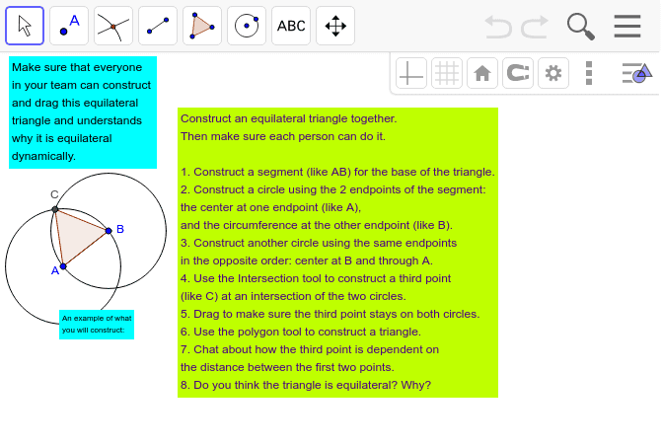

Questions.
Did you construct your own equilateral triangle?
Did you use the DRAG TEST to make sure it works properly?
The equilateral construction opens up the world of geometry; if you understand how it works deeply, you will understand much about geometry.
In geometry, a circle is defined as the set of points that are all the same distance from the center point. So, every radius of a certain circle is the same length.
Drag each point in your triangle and discuss how the position of the third point is dependent on the distance between the first two points.
Is your triangle equilateral (all sides equal and all angles equal)?
Why? How do you know? Does it have to be?

Type your answer here…

Challenge 8: Find Dynamic Triangles
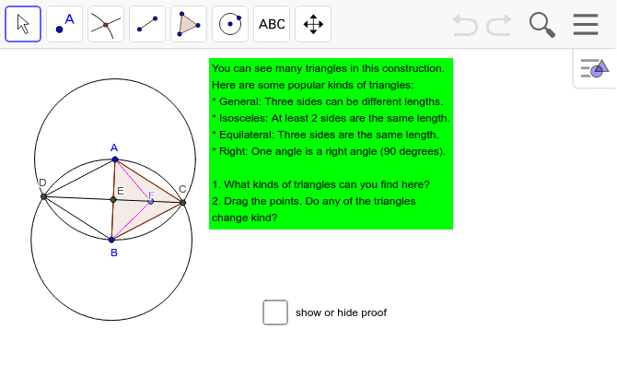

Questions.
What kinds of triangles did you find in the figure?
When you dragged the points, did any of the triangles change kind? For instance, can triangle ABF be a right triangle or equilateral? Discuss how this is possible.
Are there some kinds of triangles you are not sure about? Why are you sure about some relationships? Does everyone in your pod agree?

Type your answer here…

LEVEL 4: CIRCLE LEVEL
At this level, you will start to explore circles.

Challenge 9: Construct the Midpoint

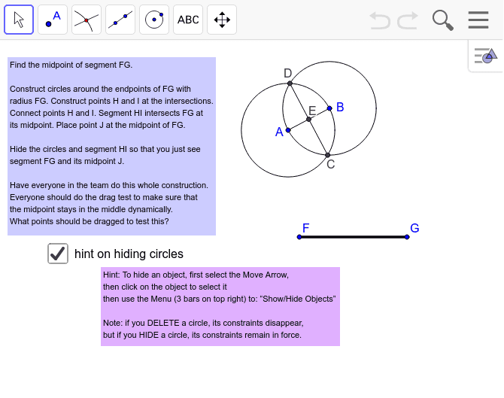

Questions.
Do you think that point E is in the middle of line segment AB?
Do you think that point E is in the middle of line segment CD?
Do you think your point J is in the middle of line segment FG?
Can you prove that any of these are true (without measuring)?

Type your answer here…

Challenge 10: Construct a Perpendicular Line

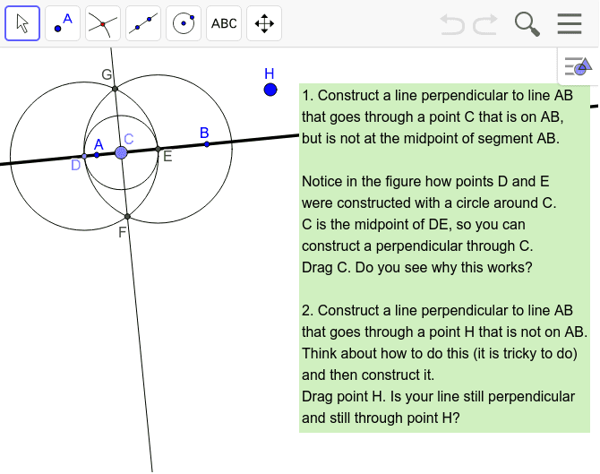

Questions.
Compare this Challenge with Challenge 9. That construction of the midpoint also constructed a perpendicular. Challenge 10 extended the approach to construct a perpendicular through a point C that was not the midpoint of AB by making a segment DE that has midpoint C. Can you explain why this works?
Can you extend the construction in this Challenge to work through a point H that is not on line AB at all?
Can you explain how your extension works? Does is still work when you drag point H all around?

Type your answer here…

Challenge 11: Construct a Parallel Line

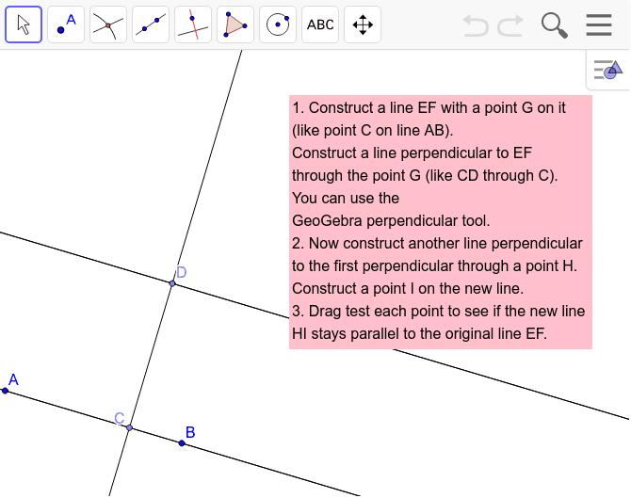

Questions.
Do you see how to use the GeoGebra perpendicular line tool in the toolbar?
It constructs something like you did in the last Challenge and hides all the construction lines and circles. Of course, you could also do the construction yourself. Most GeoGebra tools just automate constructions to save you steps. Do you prefer to do the construction yourself just using the elements of geometry: points, lines and circles?
Did your new line (HI) stay parallel to your original line (EF) no matter what points you dragged?
Explain why a perpendicular to a perpendicular is a parallel line.
Imagine riding your bike in a city with a grid of streets. If you make two right turns, you will be riding a street parallel to your original street. Two more right turns (at right angles on the grid) might bring you back to your original street.
If a right angle is 90 degrees, how many degrees is two right angles?

Type your answer here…

Continue to "Construction Pod Game: Part B"
Congratulations on mastering Part A! You now know how to construct basic geometric elements and relationships. In Part B you will learn how to make one element dependent upon another and how to copy lengths and angles that are interdependent. Part B starts on Level 5: Dependency Level.

Game Part B
The Pod Game is a series of challenges for your pod to construct interesting and fun geometric figures. It is divided into five Parts. This is Part B. If your pod has not yet completed Part A, please go to Part A. Put your Pod together again with three, four, five or six people from anywhere in the world who want to play the game together online. Collaborate, share ideas, ask questions and enjoy.

LEVEL 5: DEPENDENCY LEVEL
This level will explore the idea that some parts of a GeoGebra construction are designed to be dependent on other parts. Understanding how this works is the key to understanding geometry. Euclid's book written 2,500 years ago showed how to construct dependencies.
Euclid's book, "Elements" of Geometry, was read by more people in history than any other non-religious book. We still use Greek letters for labeling angles and Greek terms like "isosceles" ("same legs") and "equilateral" ("equal sides").

Challenge 12: Triangles with Dependencies
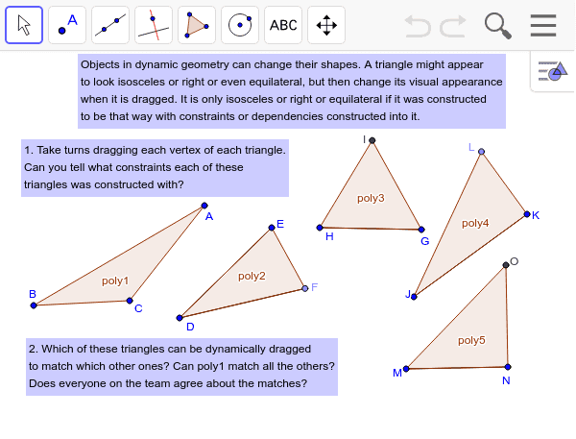
What is constrained for each of these triangles: poly1, poly2, poly3, poly4 and poly5?
Drag each vertex point to see if you can change the type of angle or the relationships of the sides.
Can you drag poly1 and each of its points so that it exactly covers any of the other triangles?
Can you drag any other triangle and each of its points so that it exactly covers any of the other triangles?
Can you name the type of each triangle?

Type your answer here…

Challenge 13: An Isosceles Triangle
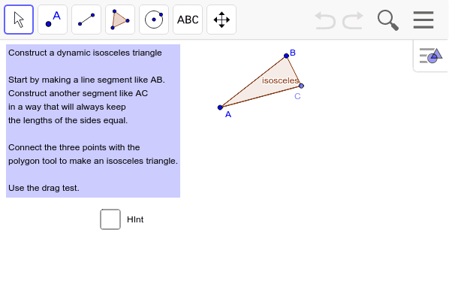
Did you figure out how to do this challenge without looking at the hint?
Did you think about the definition of a circle, where all radii are equal length?
Can you drag your isosceles triangle to look like a right triangle or an equilateral triangle?
How do you think about the fact that it is always isosceles, but can sometimes look (or even measure) right or equilateral?

Type your answer here…

Challenge 14: A Right Triangle
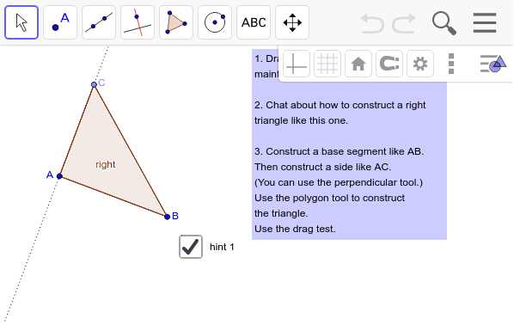
Did you use the perpendicular tool or did you construct the perpendicular to your base segment going through one of its endpoints (like in Challenge 10)?
Remember that a right angle measures 90 degrees. Can you construct a figure that combines two right triangles and shows that a straight line is an angle of 180 degrees?
Can you construct a figure that combines four right triangles and shows that a circle has 360 degrees?

Type your answer here…

Challenge 15: An Isosceles-Right Triangle
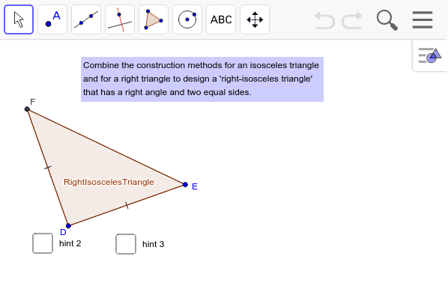
Did you need the hints to do this?
Is it interesting to you that one figure can have more than one dependency built into it?
Why would this be a powerful idea? Now you can combine multiple dependencies in one figure or multiple figures (like four right-isosceles triangles) in one larger figure (like a square) with many dependencies.

Type your answer here…

LEVEL 6. COMPASS LEVEL
In this level, you will learn how to use the GeoGebra compass tool. This is a very handy tool, but is tricky to use. It allows you to copy a length from one segment to another, making the second segment's length dependent upon the first one.

Challenge 16: Copy a Length
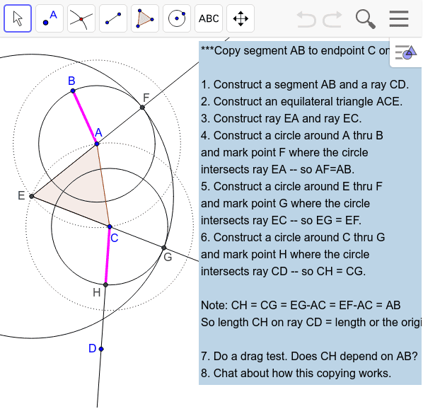
Can you do this whole construction? Can you even follow it step-by-step?
Imagine the ancient Greeks who invented geometry thinking up this complicated procedure.
This method of copying a length is presented in the beginning of Euclid's book, because it is needed for many other constructions and proofs. It is preceded by the method for constructing an equilateral triangle (which you did in Challenge 7), because that is used in this method.
Did you ever hear that "equality is transitive.”? That means that if A=B and B=C then A=C. Euclid use this to construct a long series of equal length segments to prove that the length of the final segment CH is equal to the length of the original segment AB. The equalities are based on the fact (or definition or axiom) that all radii of the same circle are equal length segments.
Drag points A, B or C to see how the length of AB is copied no matter where these points are dragged.

Type your answer here…

Challenge 17: Use the Compass Tool
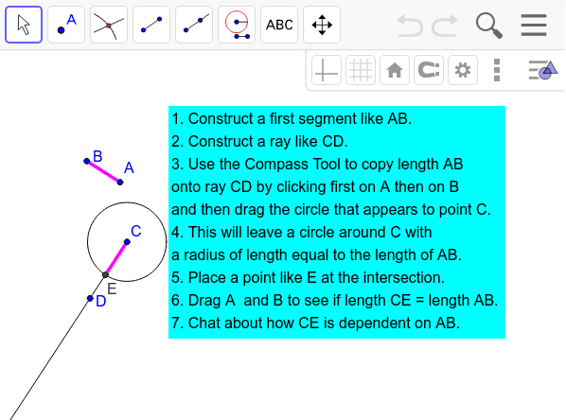
Using GeoGebra's compass tool is like using a physical compass (or caliper). You put one end at point A and one end at point B to set a span of length AB.
Then move the compass to a desired point C. The other end of the compass can then be put anywhere on a circle around point C of radius AB.
What happens to segment CE when you drag segment AB or one of its points?
Next time you want to transfer a segment length, will you use the compass tool or do the construction from Challenge 16?

Type your answer here…

Challenge 18: Make Dependent Segments
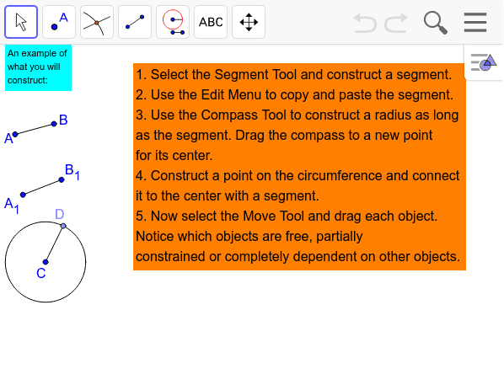
In this challenge, you can see the difference between copying a length to a new segment (so that the new version is still dependent on the original segment) and using copy-and-paste to make a static copy of a length, which is not dependent on changes of the original segment.
Which points, segments or circles are free to be dragged without constraint?
Which are completely dependent and can only be moved indirectly be dragging another point upon which it is dependent? Are there any that can be moved somewhat, but only in a constrained way?

Type your answer here…

Challenge 19: Add Segment Lengths
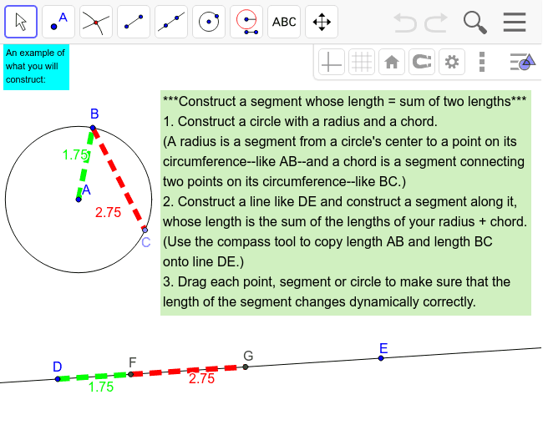
For this challenge, the lengths of some segments are shown. You can show the length of a segment by selecting the segment with the arrow tool and then going to the menu item "Object Properties." Check the box for "Show Label" and select "Value" for the label.
In geometry, you never really have to measure lengths or angles -- you just construct them to have the values you want. But it is sometimes reassuring to show their measures when you are learning with GeoGebra.
Were you able to construct a segment whose length is equal to the lengths of two other segments?
Can you construct a triangle and then construct a line segment whose length is equal to the sum of the lengths of the three sides of the triangle? Does is still work when you drag the vertices of the triangle?

Type your answer here…

Challenge 20: Copy vs. Construct a Congruent Triangle
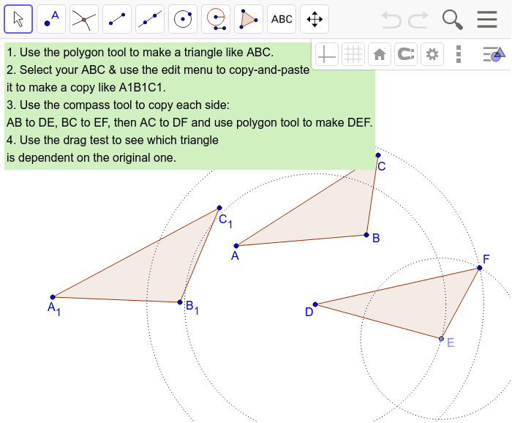
Were you able to make both kinds of copies of your triangle?
Did you have any problems or discover any tricks?
Describe in your own words the difference between copying with copy-and-paste versus copying with the compass tool.

Type your answer here…

Challenge 21: Construct a Congruent Angle
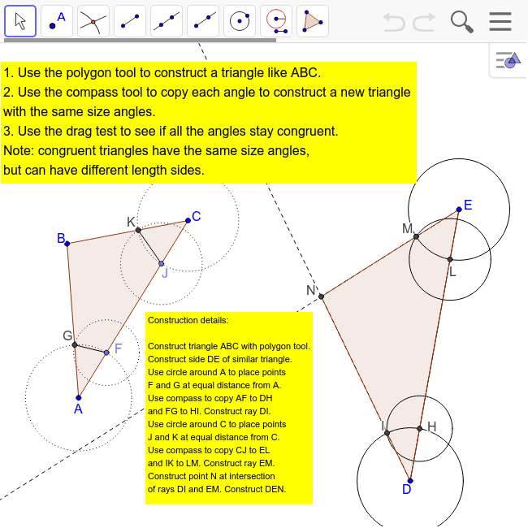
Did you understand how to copy the angles?
To copy an angle like BAC to a new angle like HDI requires two copies of lengths using the compass tool. First, use the compass to measure out from vertex A to some distance (like AF) out one of the sides (it does not matter what distance out).
Then copy the distance to vertex D, creating DH, which equals AF. Also mark points G and I, where the compass crosses the other sides of the angles at A and D. Now use the compass tool to copy the distance FG to H and mark point I where the two circles for the compass lengths cross and construct a ray from point D going through point I. Now lengths AF = AG = DH = DI. The new angle HDI is the same size as angle FAG because the distance between the two sides of each angle is an equal length at the same distance out the sides.
GeoGebra does not have a tool for copying angles. You have to construct the equal angle using the compass tool.
Do you understand how to construct a triangle "similar" to triangle ABC?
Summarize in your own words how to construct a similar triangle by copying the three angles.
Work with your teammates in your pod to write a brief proof of how you know the new triangle is similar to the original one.

Type your answer here…

Continue to "Construction Pod Game: Part C"
Congratulations on mastering Part B. You now understand some of the most important methods of constructing geometry figures. In Part C, you will explore triangles in more depth, especially congruent and inscribed triangles. Part C starts on Level 7: Congruence Level.

Game Part C
If your pod has not yet completed Part B, please go to Part B.
Put your Construction Crew Pod together again with three, four, five or six people from anywhere in the world who want to play the game together online. Collaborate, share ideas, ask questions and enjoy.

LEVEL 7: CONGRUENCE LEVEL
This level will explore the idea of deductive proof in geometry. This was the great discovery in mathematics, that you could show by careful argument why something had to be true. In particular, a set of theorems about congruent triangles are very handy for proving many things in geometry. Understanding them will let you tackle some difficult challenges about inscribed polygons.

Challenge 22: Combinations of Sides and Angles of Triangles
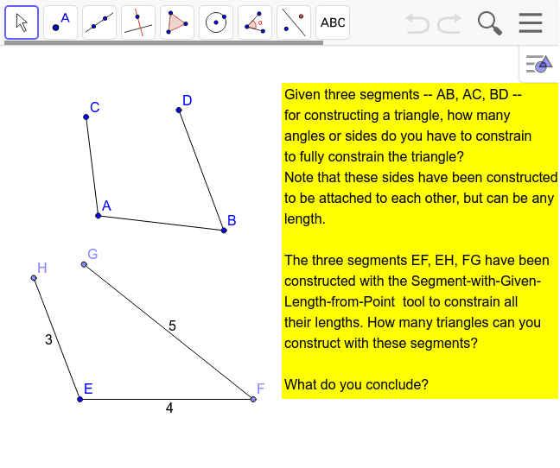
How many ways can you bring end-points G and H together to form a triangle?
Given that their lengths are all constrained, what does that imply about the angles?
If the lengths are not constrained, are there any limits on the size of the angles or sides when end-points C and D are brought together?
What if the three angles are fixed? For instance, if they are all 60 degrees? Or 30, 60 and 90 degrees?
Can there be a combination of some side lengths and some angle sizes that determine a fixed triangle?

Type your answer here…

Challenge 23: Side-Side-Side (SSS)
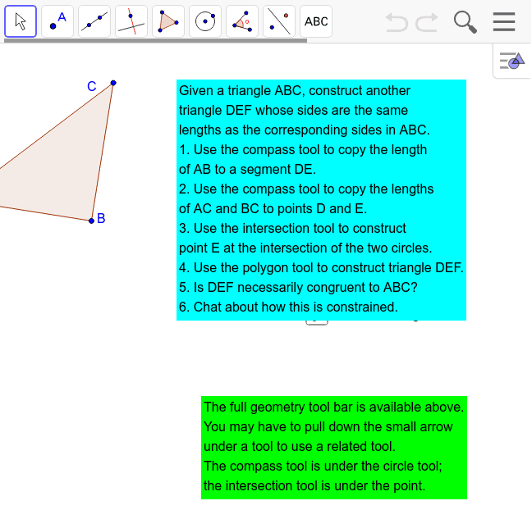
When you created triangle DEF, was it congruent to ABC? How could you tell?
Can you state a theorem (a provable rule) that summarizes what you discovered?
In some geometry books, this is called the "Side-side-side" (SSS) rule: If two triangles have the same three side lengths, then the triangles are congruent.
Many conclusions in geometry can be proven using this theorem.

Type your answer here…

Challenge 24: Side-Angle-Side (SAS)
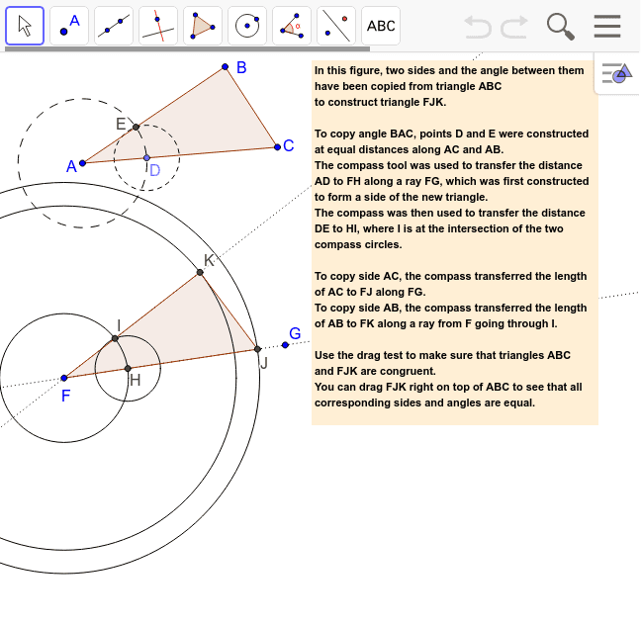
Can you recreate this pair of triangles: any triangle ABC and another triangle that has one angle and the two sides forming that angle congruent to the corresponding parts in ABC?
Can you drag those triangles to show that they are congruent and remain congruent no matter how triangle ABC and its vertices are dragged?
The theorem you have explored is called "Side-Angle-Side" or "SAS".
Are two triangles necessarily congruent if they have one angle and two sides congruent, but the angle is not between the two sides?

Type your answer here…

Challenge 25: Angle-Side-Angle (ASA)
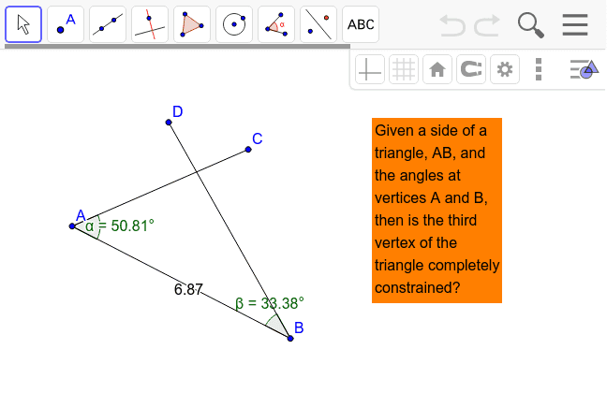
Can you copy segment AB and the angles at A and B to a new segment?
Make a polygon connecting the intersection of the sides with the two copied vertices.
There is a theorem called "Angle-Side-Angle" or "ASA" that says that if two triangles have two angles and the included side congruent, then the two triangles are congruent.
Do you see that this is always true as you drag the vertices of the original triangle?
Does this mean that if two triangles have two angles and any side equal, then the two triangles are congruent?
Note that the three angles of a triangle always add up to 180 degrees. So, if two of the angles are fixed, then so is the third (180 minus the sum of the other two angles). Does this mean that two angles and any side will determine a congruent triangle?

Type your answer here…

Challenge 26: Side-Side-Angle (SSA)
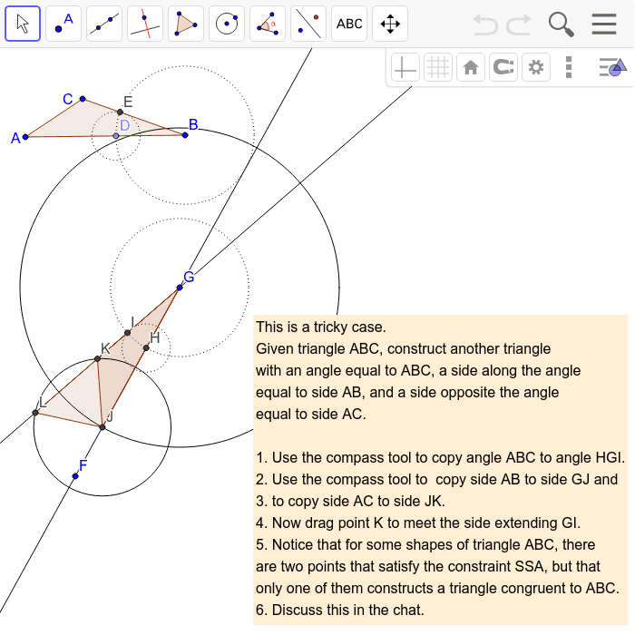Can you
Could you construct the two triangles?
When is it possible to construct two different triangles with SSA fixed?
What combinations of congruent sides and/or angles determine congruent
triangles? E.g., SSS and SAS, but not SSA.

Type your answer here…

LEVEL 8. INSCRIBED POLYGON LEVEL
This level presents some challenging geometry problems involving a geometric figure inscribed inside another figure.

Challenge 27: The Inscribed Triangles Challenge Problem
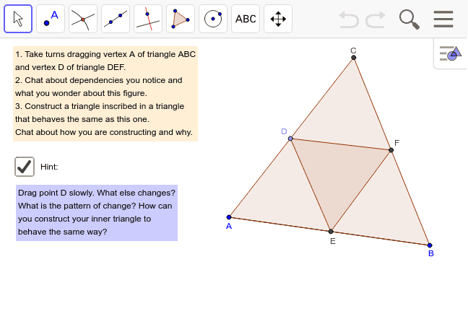Triangle DEF is "inscribed" in triangle ABC. This means that DEF fits exactly inside
You know how to construct an equilateral triangle like ABC from Challenge 7. What happens when you try to construct the second equilateral triangle with a vertex on each side of the first triangle?
In geometry, a point can be defined by two lines (or segments or circles), where they cross. The point's location is determined by or located at the crossing of the two lines. However, a point cannot be defined by three lines -- that would be overdetermining the point. Try to construct three lines (or segments or circles) to cross in one location and then use the point tool to place a point at that intersection. What happens?
Follow the hint. Analyze how things evolve as you drag point D along side AC.
Describe what you see about dependencies and relationships among items in the figures.
Try to construct a pair of inscribed triangles that reproduce those dependencies or relationships.
Work together with your team-mates in your pod. This is a difficult challenge that usually takes people at least an hour to solve.
If you solve it, can you say why it works?

Type your answer here…

Challenge 28: Inscribed Squares
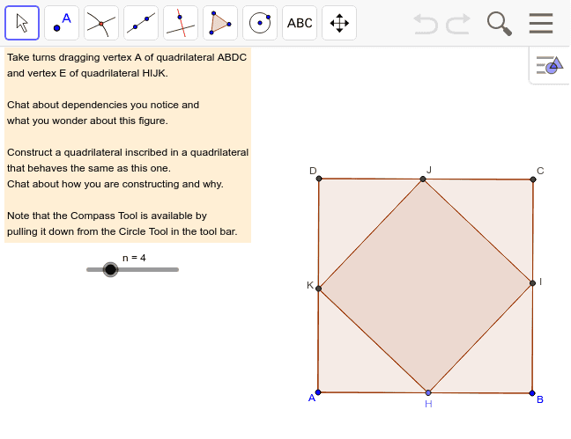
A "quadrilateral" is a four-sided figure. A pentagon has 5 sides. A hexagon has 6 sides. An octagon has 8 sides.
A "regular" quadrilateral has four sides of equal length and four angles of equal size (right angles). It is a square.
The slider in this challenge produces inscribed regular polygons of 3 to 9 sides. You can use the Regular Polygon tool (under the Polygon tool in the menu to create a regular polygon with a selected number of sides.
Can you construct an inscribed square? What did you notice by dragging point H and how did you use that in your construction?
Can you construct an inscribed regular pentagon? An inscribed regular hexagon? An inscribed regular octagon?

Type your answer here…

Challenge 29: Prove Inscribed Triangles
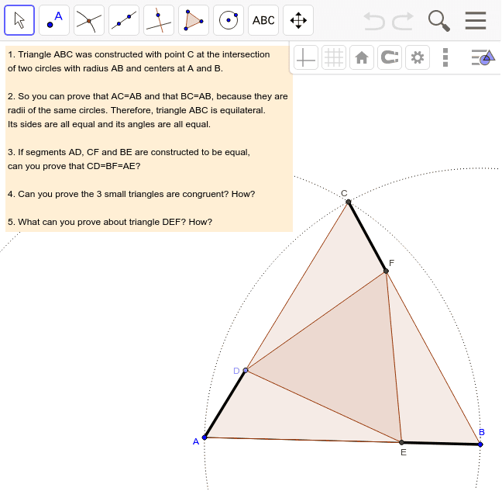Work with your team-mates in your pod to complete the following proof that triangle DEF is equilateral:
Given an equilateral triangle ABC and points D, E, F on its sides such that AD = BE = CF, prove that inscribed triangle DEF is equilateral.
If AD = BE, then CD = AE because CD = AC - AD and AE = AB - BE; where AC = AB because they are equal sides of an equilateral triangle. Subtracting equal lengths from equal lengths leaves equal lengths….
Triangles ADE, BEF and CDF are congruent triangles because they have equal corresponding sides and included angles (SAS). Therefore, corresponding sides DE = DF = DE, so the inscribed triangle DEF is equilateral, which is what was to be proven.

Type your answer here…

Continue to "Construction Pod Game: Part D"
Congratulations on mastering Part C. You now understand some of the most important methods of proving theorems about geometry figures. Part D introduces a different approach to doing geometry that is much more recent than Euclid's approach. It also presents challenges involving quadrilaterals (four-sided figures), which have more options for dependencies than triangles. Part D starts on Level 9: Transformation Level.

Game Part D
If your pod has not yet completed Part C, please go to Part C.
Put your Construction Crew Pod together again with three, four, five or six people from anywhere in the world who want to play the game together online. Collaborate, share ideas, ask questions and enjoy.

LEVEL 9: TRANFORMATION LEVEL
This level will explore a different approach in geometry: transformations. There are different kinds of transformations, like translation, reflection and rotation.
Transformations is not part of Euclid’s system of geometry, but is a newer way of constructing geometric figures.
When you dragged a figure in the previous levels, the figure moved from its original position to the new one. When you transform a figure in this new level, the figure remains in its original position and a new copy of the figure appears in addition, in its new position. This takes some getting used to, but it has advantages in making it easier to compare the figure before and after the transformation, to help you understand what has changed.

Challenge 30: Translate by a Vector
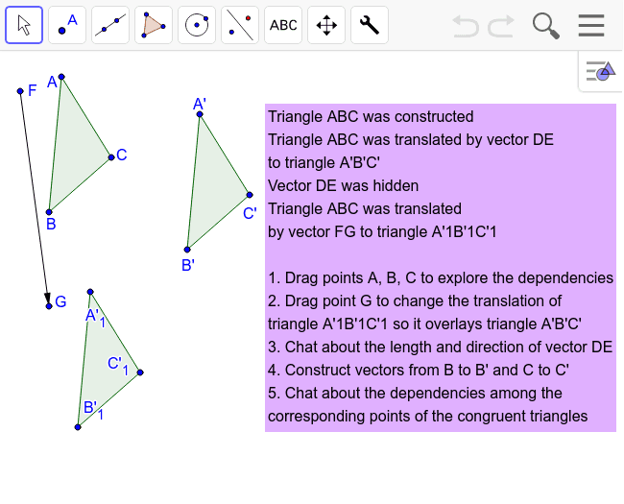See the menu item for reflection about a line (the diagonal line with a blue point on one side reflected by a red point on the other). There are several GeoGebra tools for geometric "transformations". Try these tools out in this set of five Challenges.
What did you notice that surprised you about how the translation transformation works in dynamic geometry?

Type your answer here…

Challenge 31: Reflect About a Line
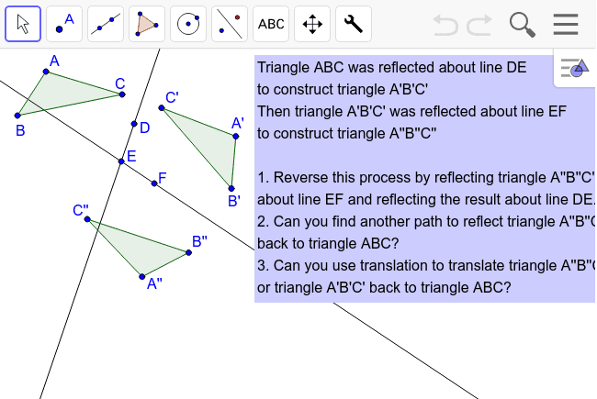
Could you reverse the two reflections to get back to the original position?
Could you find another path of reflections to get back to the original position?
Can you translate either of the reflections back to the original?
Are the three triangles congruent to each other? Could you lay them on top of each other by translating them around?
If you reflect ABC about line DE and then about line EF does that have the same result as reflecting ABC about line EF and then about line DE?

Type your answer here…

Challenge 32: Rotate Around a Point
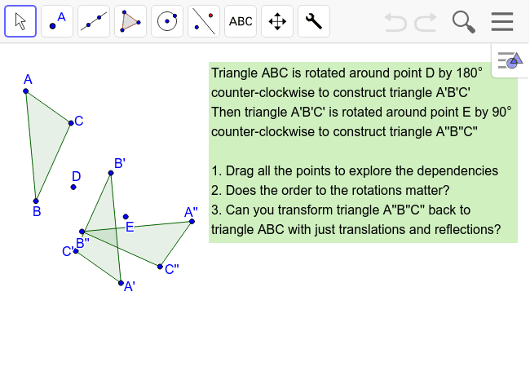How are rotations different from translations?
Drag point D and then describe how ABC is rotated.
Does the order of the two rotations matter? Would the final triangle be the same if ABC was first rotated about point E and then about point D?
Give an example of a reflection of ABC followed by a translation that would end up the same as A'B'C'.

Type your answer here…

Challenge 33: Combine Transformations
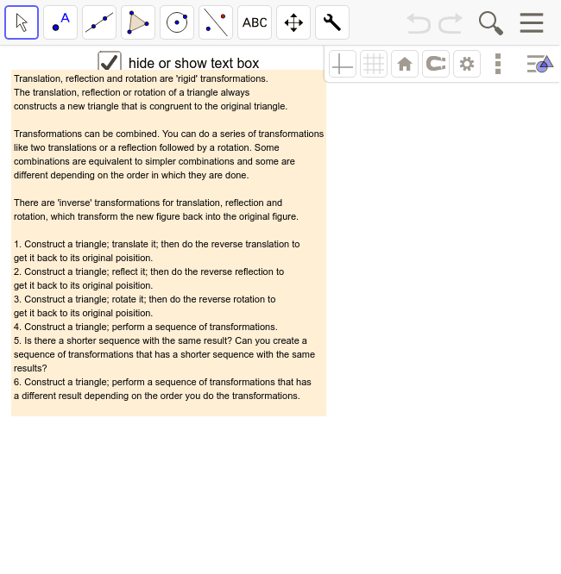Describe the transformations you did.
Did you have any trouble doing the different tasks?
Can you replace every translation with a series of reflections and rotations?
Can you replace every reflection with a series of translations and rotations?
Can you replace every rotation with a series of reflections and translations?

Type your answer here…

Challenge 34: Create Dynamic Patterns
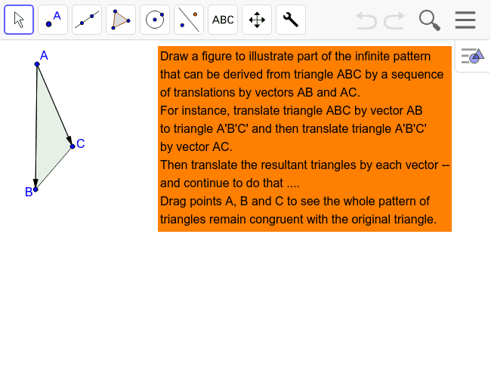
Can you make dynamic patterns of triangles using a repeated rotation or a repeated reflection?
Then drag points to move the pattern in interesting ways.
What kind of pattern did you create? Did it behave like you expected?

Type your answer here…

LEVEL 10. QUADRILATERAL LEVEL
In this level, you will explore four-sided figures. There are many more possibilities with four sides than with just three.

Challenge 35: Construct Quadrilaterals with Constraints
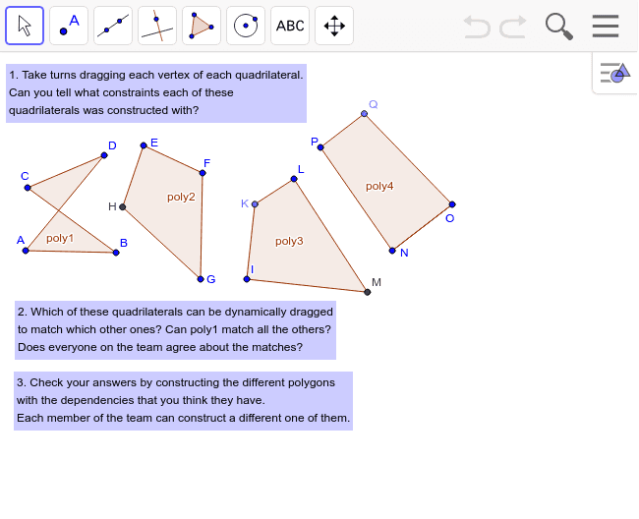What constraints do you think were constructed into poly1?
What constraints do you think were constructed into poly2?
What constraints do you think were constructed into poly3?
What constraints do you think were constructed into poly4?
Were you able to construct your own quadrilateral with the same constraints as one of the original ones?
Did you drag it to make sure it had the same behavior?

Type your answer here…

Challenge 36: Construct a Rhombus
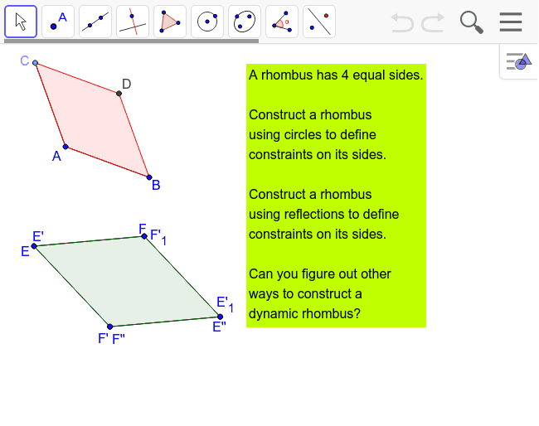Describe the steps you used to construct a rhombus using circles.
Describe the steps you used to construct a rhombus using reflections.
Describe another way to construct a four-sided figure with equal side lengths (a regular quadrilateral or a "rhombus").

Type your answer here…

Challenge 37: Quadrilateral Areas
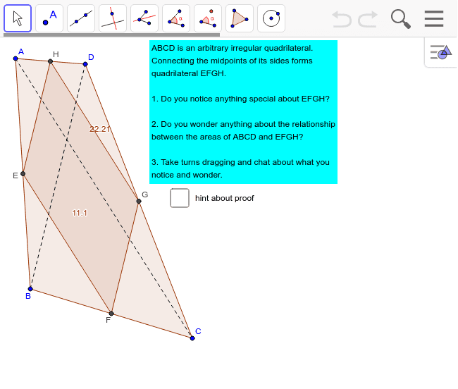 Were you surprised about the relation of the areas of the inscribed quadrilateral to the inscribing (exterior) quadrilateral? (The areas are displayed in the figure and change as you drag the vertices.)
Were you surprised about the constraints on the inscribed quadrilateral being different from those on the inscribing (exterior) quadrilateral? Did you notice the relationship of opposite sides and of opposite angles?
The proof of these features of the inscribed quadrilateral is complicated. You probably do not know enough theorems to prove it yourself. Are you able to follow the argument in the proof outlined in the hint?

Type your answer here…

Challenge 38: Build a Hierarchy of Quadrilaterals
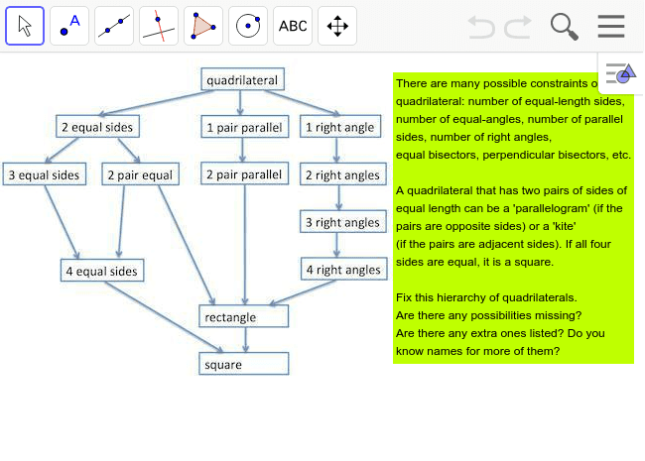Do you understand this diagram of constraints or dependencies?
For instance, a square is a quadrilateral with all of the constraints: each of its angles is a right angle and each of its side lengths is dependent on the first side length. A rectangle is not constrained to have all its side lengths equal, but it must have two pairs of equal length sides (opposite each other) and four right angles.
Can you make a diagram of this same hierarchy with the names of figures (like square, rhombus, kite, parallelogram, etc.) instead of the descriptions of constraints? ("Quadrilateral", "rectangle" and "square" are already shown.)
Are there some possible figures that do not have names? Are there some more possible combinations of constraints that could be added to the diagram?
In Challenge 15, you constructed an isosceles-right triangle. Can you construct an isosceles-right quadrilateral now (with two equal sides and one right angles)? Where would it go in the diagram?
Do you see how the diagram shows that all squares are rectangles? Do you see how the diagram shows that a rectangle can be a square, but it does not have to be?

Type your answer here…

Congratulations on mastering Part D. You now understand some of the most important methods of transforming theorems about geometry figures and working with quadrilaterals. Part E presents challenges for advanced students, who have completed all the previous Parts. Part E starts on Level 11: Advanced Geometer Level.

Continue to "Construction Pod Game: Part E"

Game Part E
If your pod has not yet completed Part D, please go to Part D. Put your Construction Crew Pod together again with three, four, five or six people from anywhere in the world who want to play the game together online. Collaborate, share ideas, ask questions and enjoy.

LEVEL 11: ADVANCED GEOMETER LEVEL
This level will introduce you to a series of intriguing points within triangles. These special points are interconnected in mysterious ways.

Challenge 39: The Centroid of a Triangle
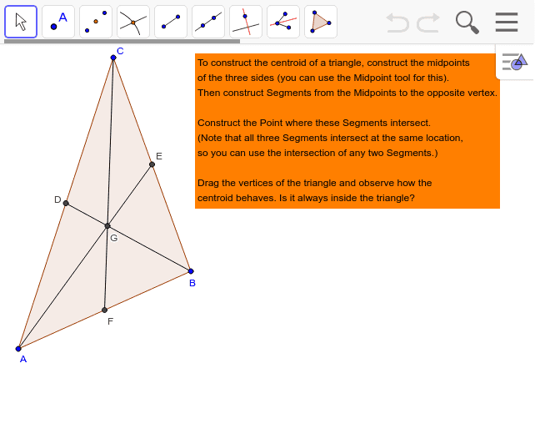

Can you create a triangle with the polygon tool and construct its centroid?
If you construct an isosceles triangle, where is its centroid? How about for a right triangle?

Type your answer here…

Challenge 40: The Circumcenter of a Triangle
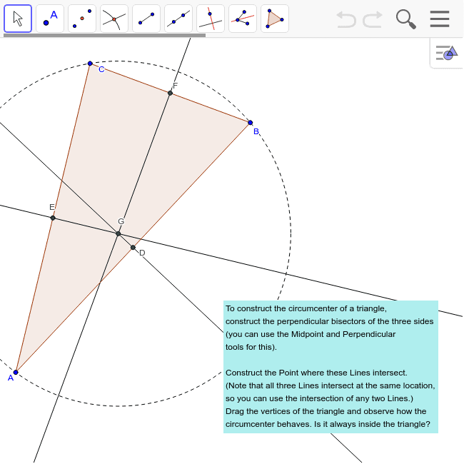
If you construct a circle with its center at the circumcenter of any triangle and its radius going to one of the triangle's vertices, the circle will go through all three vertices. That is the definition of the "circumcenter" (the center of the circumference or circle of the triangle).
Were you able to construct the circumcenter of your own triangle?
Did you drag the vertices to see if the circumcenter is always inside the triangle?
Do you wonder why all three perpendicular bisectors of the sides meet at the same point? (Remember that a point is defined by just two lines crossing.)

Type your answer here…

Challenge 41: The Orthocenter of a Triangle
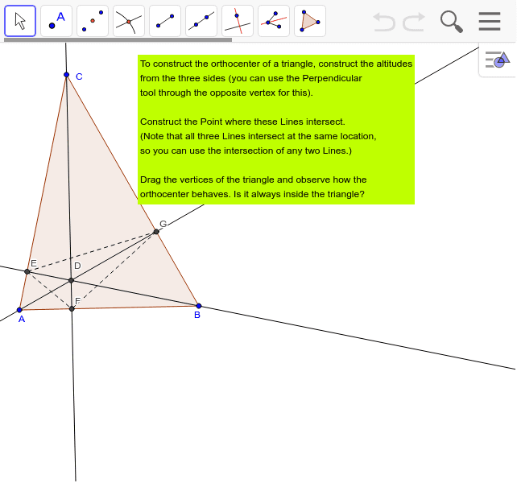
The "altitude" of a triangle is the line segment from the base of the triangle perpendicularly to the opposite vertex. If you take AB as the base, then FC is the altitude, if FC is perpendicular to AB.
You may know that the area of a triangle is 1/2 x base x altitude. How would you prove this? Construct a rectangle and connect two opposite vertices with a diagonal line segment, forming two congruent right triangles. The area of the rectangle is the base x height. So, what is the area of each right triangle? This proves a special case of a right triangle's area.

Type your answer here…

Challenge 42: The Incenter of a Triangle
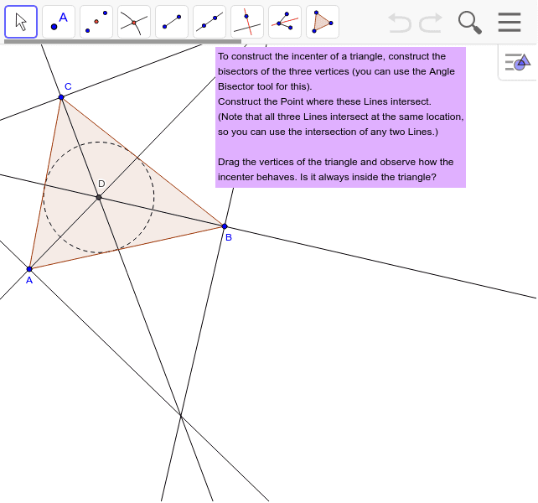
A circle with center at the incenter of a triangle and radius to a point where a vertex bisector meets a triangle side will be inscribed in the triangle. The inscribed circle will touch each side of the triangle at exactly one point (it will be "tangent" to the side).
Can you construct a triangle with a circle inscribing the triangle and a circle inscribed inside the triangle?

Type your answer here…

Challenge 43: The Euler Segment of a Triangle
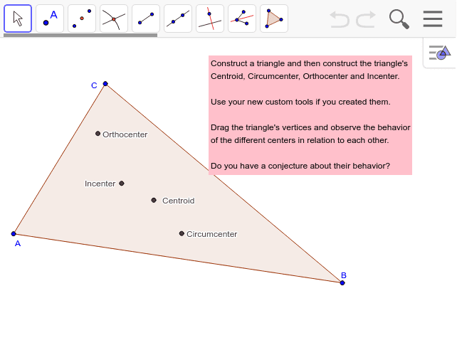
You can create new tools in GeoGebra. For instance, you can go back to your constructions of the centroid, circumcenter, orthocenter and incenter and make your own custom tools. Then you can use your custom tools to place each of these points in a new triangle here.
To define a custom tool, go to the GeoGebra menu under Tools and select Create New Tool. Follow the steps: 1. select the triangle and the special point as output your computer from the Manage Tools option under the Tools menu.
Custom tools are powerful. They are shortcuts to doing complicated things and you know exactly how they work. You can develop your own mini-domains of geometry with them. You can add new functions, like copying angles and inscribing triangles in circles.
When you drag your triangle with these four special points, do you notice any possible dependencies among them?

Type your answer here…

Challenge 44: The Nine-Point Circle of a Triangle
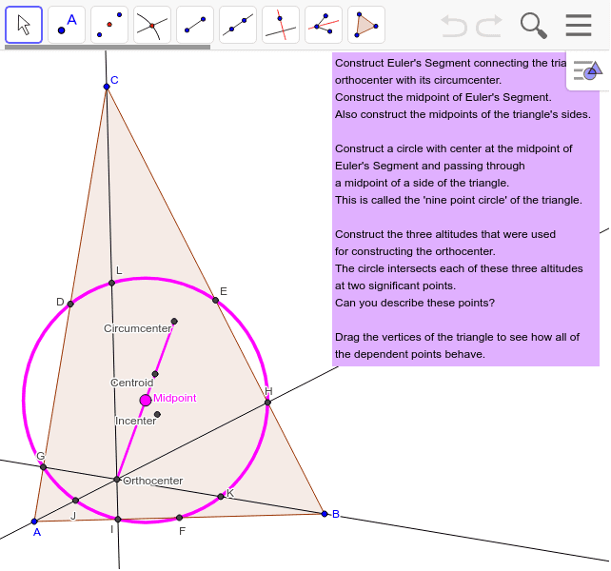Describe the nine points on the circle.
As you drag the vertices, do the nine points stay on the circle and do the circumcenter, incenter and orthocenter stay on the Euler segment, whose midpoint stays in the center of the 9-point circle?
Here are many points and lines with complicated dependencies among themselves and the vertices of the triangle. Can you prove why the nine points are all on the same circle? Can you prove why the circumcenter, incenter and orthocenter are all on the same line segment, whose midpoint is the center of the circle. If you looked carefully at the detailed steps in constructing all these points, lines and circles, you could work out much of the proof -- often using equalities of congruent triangles proven by theorems like SSS, SAS and ASA.

Type your answer here…

LEVEL 12: PROBLEM SOLVER LEVEL
In this level, you will solve three challenging problems.

Challenge 45: Treasure Hunt
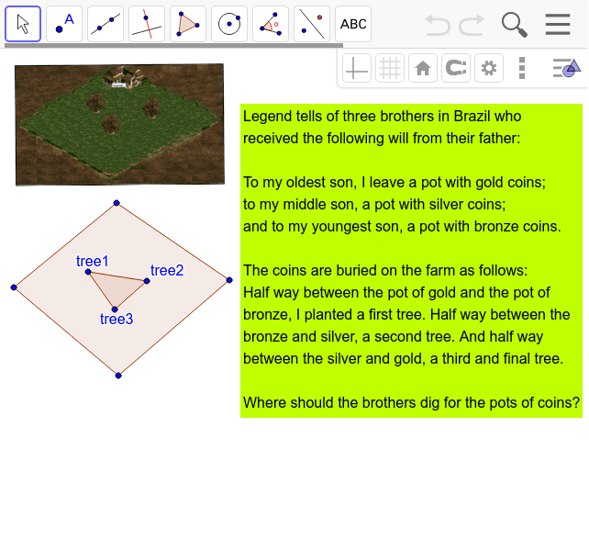

Given the locations of the three trees, how would you construct the locations of the
three pots of coins?

Type your answer here…

Challenge 46: Square and Circle
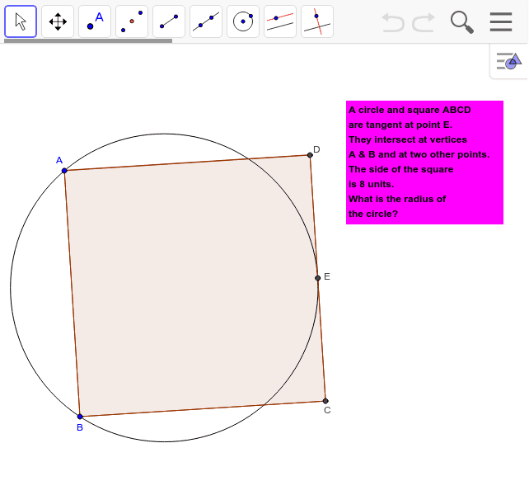How did you construct the center of the circle?
How did you figure out the radius length?

Type your answer here…

Challenge 47: Cross an Angle
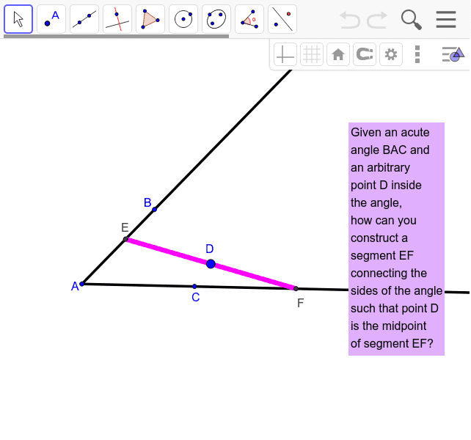
What additional lines did you have to construct to determine locations for points E and F?

Type your answer here…

LEVEL 13: EXPERT LEVEL
In this level, you will prepare to explore geometry, mathematics and the world beyond this game.

Challenge 48: How Many Ways Can You Invent?
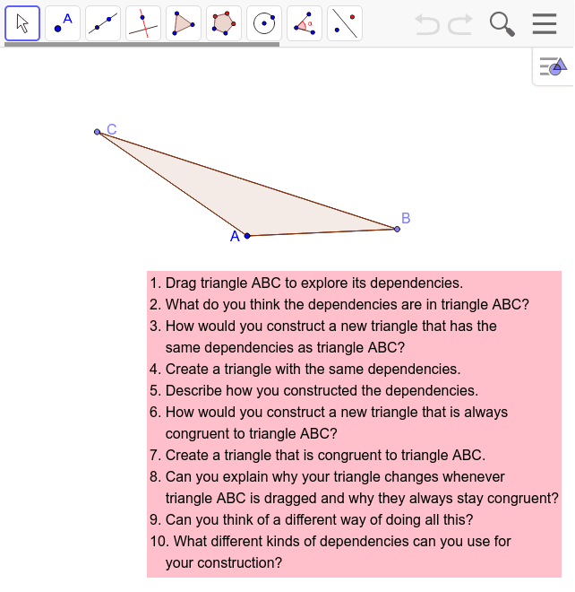
Describe the different ways that you constructed triangles that are always congruent to triangle ABC no matter how you drag A, B or C.

Type your answer here…

Challenge 49: Dependencies in the World
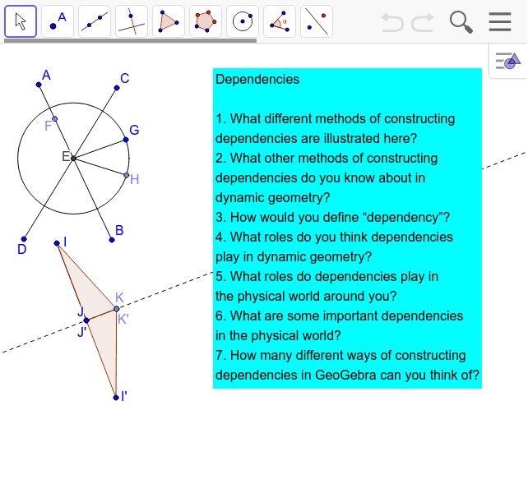

Answer questions 1 through 7 in Challenge 49 in your own words.

Type your answer here…

Challenge 50: Into the Future
Just do it!
Invent a challenge for your teammates and others who have completed the Pod Game.
Why did you choose this topic?

Type your answer here…

Continue to explore geometry and other branches of mathematics
Congratulations on mastering Part E. You now know how to use the basic tools of GeoGebra to explore dynamic geometry. You can continue to explore the extensive range of GeoGebra tools and the infinite worlds of mathematics – with your pod mates and/or on your own.

Extra Bonus Dynamic Geometry
The rest of this volume is a bonus for people who have conquered the Game. This material is not included in the online Game.

A Special Challenge
If you worked through the five levels of the Dynamic Geometry Game for Pods, then here is a challenge you might be able to meet. Personally, I found it difficult, although you know everything needed to do it. Even when I knew how to solve it, it took me a long time to figure out why it worked.
If you solve it, you can tell your pod about it. If you cannot figure out a solution, read on and see if you can understand why the solution presented later works. In mathematics, a rigorous explanation showing that something is true is called a “proof.” Proofs are very important in mathematics, although students are not often shown proofs when they learn math in school. Historically, proof originated in the early Greek invention of geometry, so that students usually are first introduced to proof when they learn geometry.
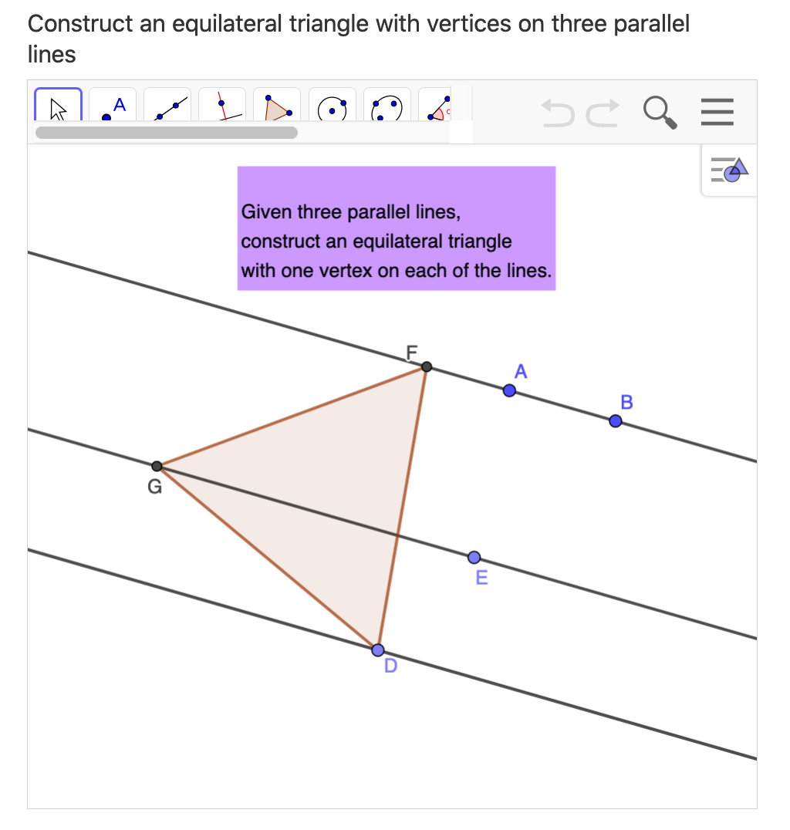

To do this special challenge, first create a line through points A and B. Then construct two lines parallel to line AB through points D and E. Now figure out how to construct an equilateral triangle like DFG that has a vertex on each of the parallel lines. How do you know your triangle is equilateral, even when the parallel lines are dragged?

Visualizing the World’s Oldest Theorem
Scientific thinking in the Western world began with the ancient Greeks and their proofs of theorems in geometry.
Thales lived about 2,600 years ago (c. 624–546 BCE). He is often considered the first philosopher (pre-Socratic), scientist (predicted an eclipse) and mathematician (the first person we know of to prove a mathematical theorem deductively). Pythagoras came 30 years later and Euclid (who collected many theorems of geometry and published them in his geometry book called Elements) came 300 years later. Thales took the practical, arithmetical knowledge of early civilizations—like Egypt and Babylonia—and introduced a new level of theoretical inquiry into it. With dynamic-geometry software, you can take the classic Greek ideas to yet another level.
Thales took a “conjecture” (a mathematical guess or suspicion) about an angle inscribed in a semi-circle and he proved why it was true. You can use dynamic geometry to see that it is true for all angles all along the semi-circle. Then you can prove that it is always true.

Construction Process
Follow these steps to construct an angle in GeoGebra inscribed in a semi-circle like the one in the Figure below. You will be able to move the angle dynamically and see how things change.
Step 1. Construct a ray 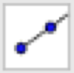 like AB.
Step 2. Construct a circle with center at point B and going through point A.
Step 3. Construct a point like point C at the intersection of the line and the circle, forming the diameter of the circle, AC.
Step 5. Construct a point like D anywhere on the circumference of the circle.
Step 6. Create triangle ADC with the polygon tool .
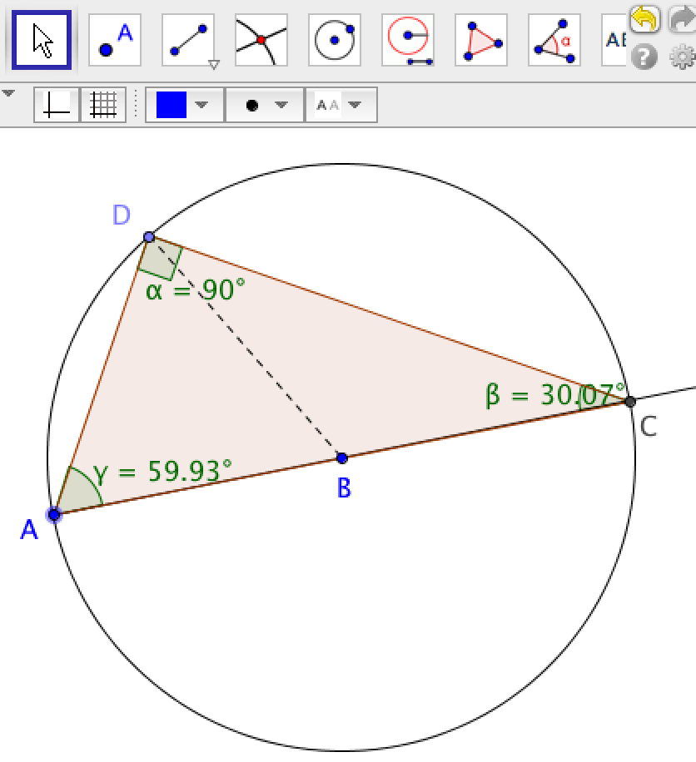
The Theorem of Thales.
Step 7. Create the interior angles 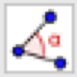 of triangle ADC. (Always click on the three points forming the angle in clockwise order—otherwise you will get the measure of the outside angle.) In geometry, we still use the Greek alphabet to label angles: α, β, γ are the first three letters (like a, b, c), called “alpha,” “beta,” and “gamma.”
Step 8. Drag point D along the circle. What do you notice? Are you surprised? Why do you think the angle at point D always has that measure?

Challenge
Try to come up with a proof for this theorem.
Hint: To solve a problem or construct a proof in geometry, it is often helpful to construct certain extra lines, which bring out interesting relationships. Construct the radius BD as a segment 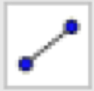.
Thales had already proven two theorems previously:
- The base angles of an isosceles triangle are equal. (An “isosceles” triangle is defined as having at least two equal sides.)
- The sum of the angles α+β+γ=180° in any triangle.
Can you see why α=β+γ in the figure, no matter how you drag point D? (Remember that all radii of a circle are equal by definition of a circle.) That means that (β+γ)+β+γ=180°. So, what does α have to be?

Visualization #1 of Pythagoras’ Theorem
Pythagoras’ Theorem is probably the most famous and useful theorem in geometry. It says that the length of the hypotenuse of a right triangle (side c, opposite the right angle) has the following relationship to the lengths of the other two sides, a and b:
c² = a² + b²
Below are figures that show ways to visualize this relationship. They involve transforming squares built on the three sides of the triangle to show that the sum of the areas of the two smaller squares is equal to the area of the larger square. The area of a square is equal to the length of its side squared, so a square whose side is c has an area equal to c².
Explain what you see in these two visualizations. Can you see how the area of the c² square is rearranged into the areas a² and b² or vice versa?

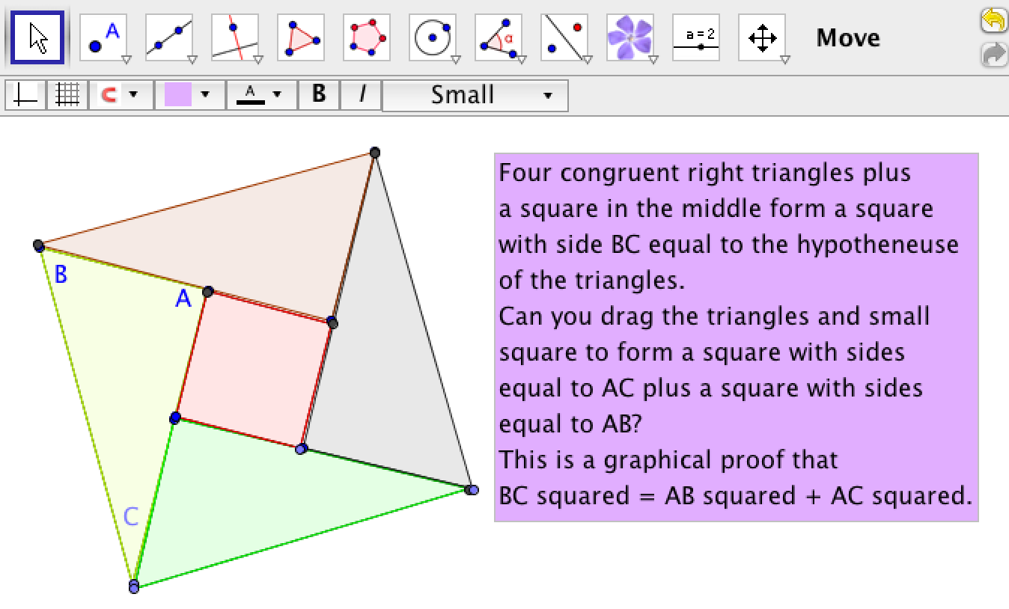
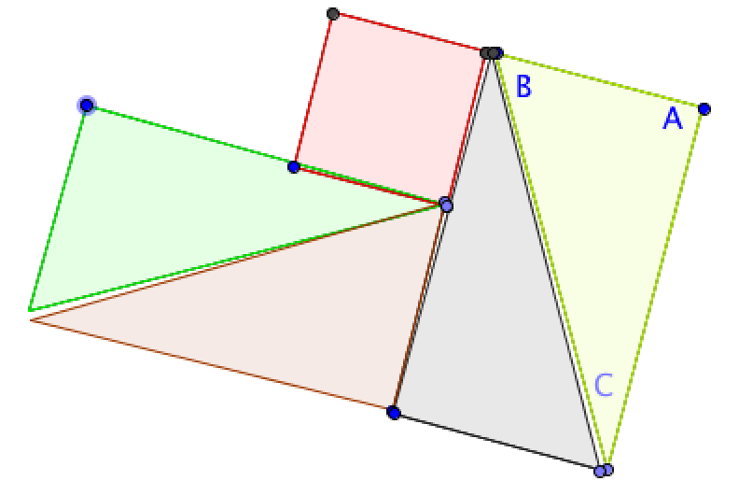.
Visualization #1 of Pythagoras' Theorem.

Notice that these are geometric proofs. They do not use numbers for the lengths of sides or areas of triangles. This way they are valid for any size triangles. In the GeoGebra tab, you can change the size and orientation of triangle ABC and all the relationships remain valid. Geometers always made their proofs valid for any sizes, but with dynamic geometry, you can actually change the sizes and see how the proof is still valid (as long as the construction is made with the necessary dependencies).
It is sometimes helpful to see the measures of sides, angles and areas to help you make a conjecture about relationships in a geometric figure. However, these numbers never really prove anything in geometry. To prove something, you have to explain why the relationships exist. In dynamic geometry, this has to do with how a figure was constructed—how specific dependencies were built into the figure. In this figure, for instance, it is important that the four triangles all remain right triangles and that they have their corresponding sides the same lengths (a, b, and c). If these lengths change in one triangle, they must change exactly the same way in the others. Can you tell what the side length of the square in the center has to be?

Visualization #2 of Pythagoras’ Theorem
The next figure automates the same proof of Pythagoras’ Theorem with GeoGebra sliders. Try it out. Move the sliders for α and s to see what they change.
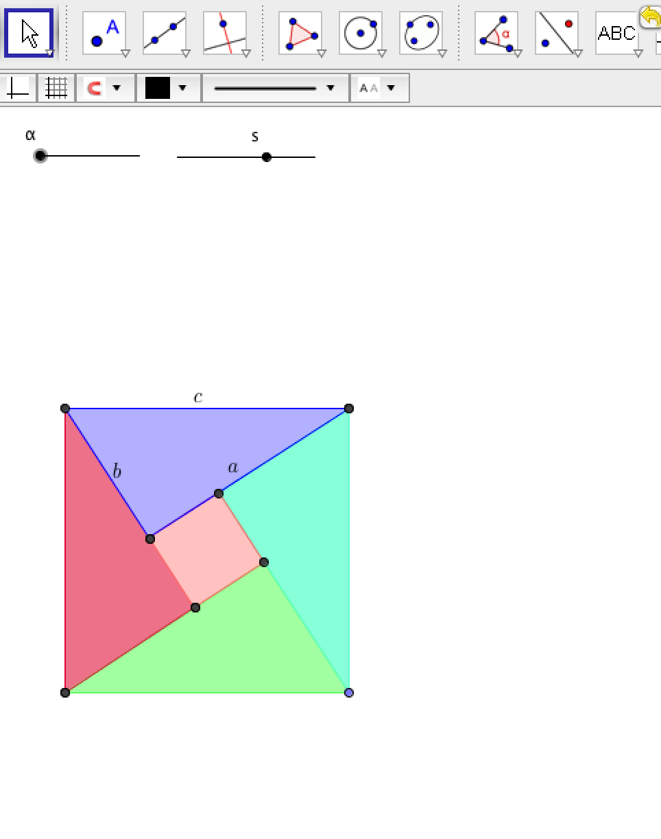
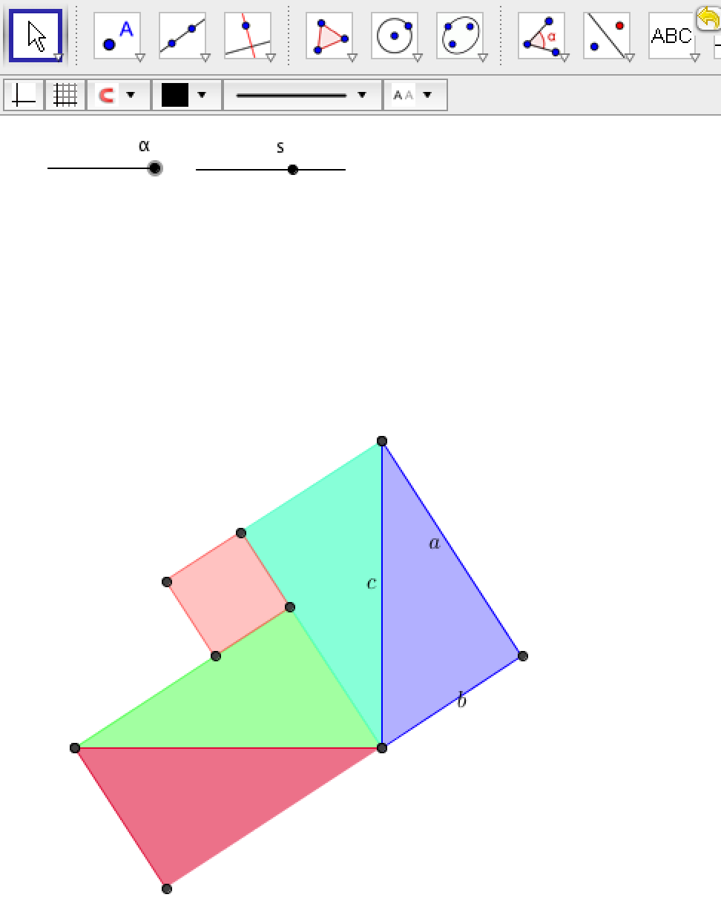
Visualization #2 of Pythagoras’ Theorem.

Visualization #3 of Pythagoras’ Theorem
The next figure shows another way to visualize the proof of Pythagoras’ Theorem. Slide the slider. Is it convincing?
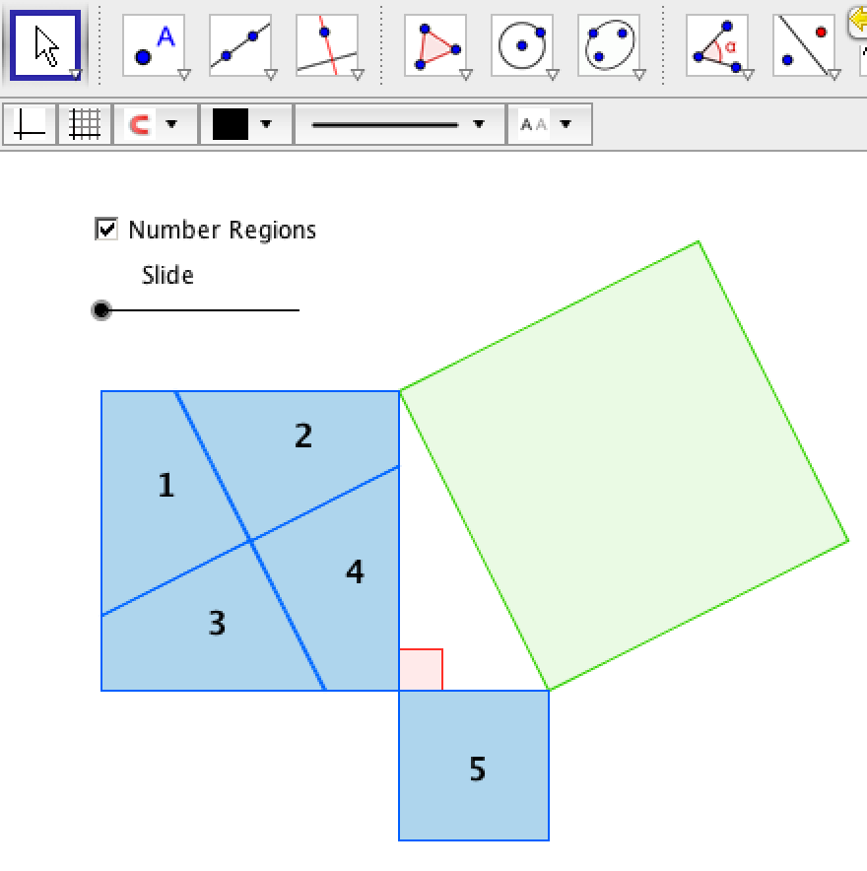
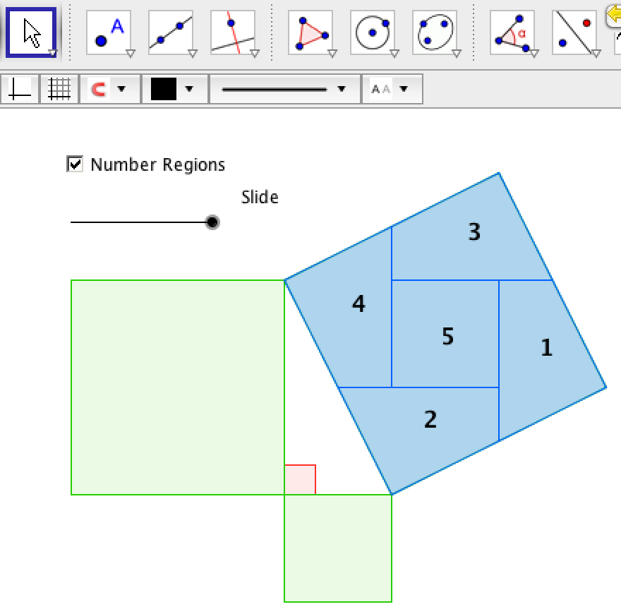
Visualization #3 of Pythagoras’ Theorem.

Visualization #4 of Pythagoras’ Theorem
The next figure shows an interesting extension of the proof of Pythagoras’ Theorem:

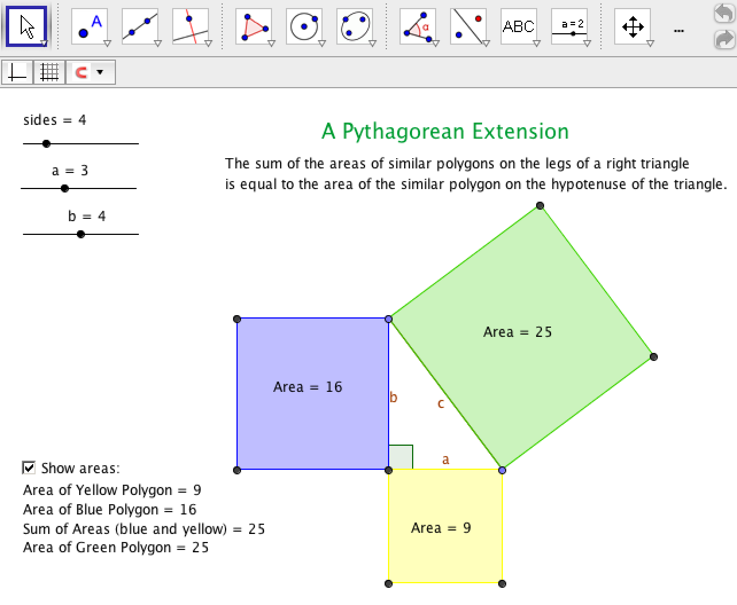
Visualization #4 of Pythagoras’ Theorem.
Can you explain why it works for all regular polygons if it works for triangles?

Visualization #5 of Pythagoras’ Theorem
Finally, here is Euclid’s own proof of Pythagoras’ Theorem in his 47th proposition. It depends on some relationships of quadrilaterals. Drag the sliders in this GeoGebra figure slowly and watch how the areas are transformed.
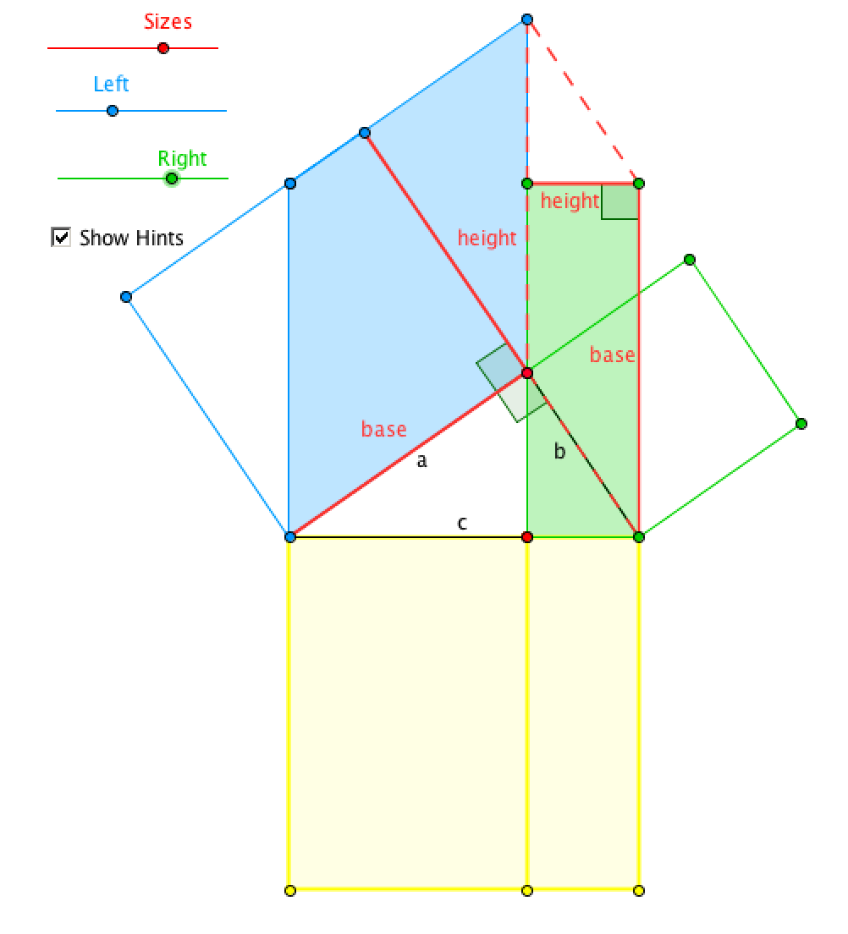
Visualization #5 of Pythagoras’ Theorem.
There are many other visual, geometric and algebraic proofs of this famous theorem. Which do you find most elegant of the ones you have explored here?

Proof of Special Challenge
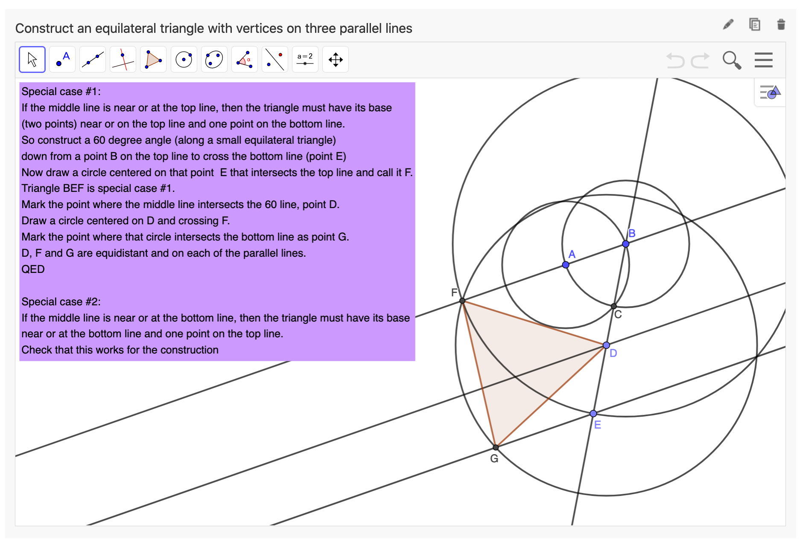

Here is the solution to the Special Challenge at the beginning of the Extra Bonus chapter. It includes a proof, based on the construction. Note that it uses two special cases to help solve and explain the construction. Considering special cases is often useful to working out a construction or a proof. While mathematical proofs can often be formal and not very insightful, they can also sometimes help to explain why or how something is true or valid. Visual proofs and proofs of special cases can contribute to such intriguing proofs.

Proof Involving the Incenter of a Triangle
In Euclid’s construction of an equilateral triangle, he made the lengths of the three sides of the triangle dependent on each other by constructing each of them as radii of congruent circles. Then to prove that the triangle was equilateral, all he had to do was to point out that the lengths of the three sides of the triangle were all radii of congruent circles and therefore they were all equal.
In this topic, you will look at a more complicated conjecture about triangles, namely relationships having to do with the incenter of a triangle. Remember from Challenge 43 that the “incenter” of a triangle is located at the intersection of the bisectors of the three vertex angles of the triangle. This topic explores how identifying dependencies in a dynamic-geometry construction can help you prove a conjecture about that construction.
The conjecture has a number of parts:
- The three bisectors of the vertex angles all meet at a single point. (It is unusual for three lines to meet at one point. For instance, do the angle bisectors of a quadrilateral always intersect at one point?)
- The incenter of any triangle is located inside of the triangle. (Other kinds of centers of triangles are sometimes located outside of the triangle. For instance, can the circumcenter of a triangle be outside the triangle?)
- Line segments that are perpendiculars to the three sides passing through the incenter are all of equal length.
- A circle centered on the incenter is inscribed in the triangle if it passes through a point where a perpendicular from the incenter to a side intersects that side.
- The inscribed circle is tangent to the three sides of the triangle.
These may seem to be surprising conjectures for a simple triangle. After all, a generic triangle just consists of three segments joined together at their endpoints. Why should a triangle always have these rather complicated relationships?
Construct the incenter of a general dynamic triangle and observe how the dependencies of the construction suggest a proof for these five parts of the conjecture about a triangle’s incenter.

Construct an Incenter with a Custom Incenter Tool.
In Challenge 44, you may have programmed your own custom incenter tool. Open the .ggt file for it with the menu “File” | “Open.” Then select your custom incenter tool. Click on three points A, B and C to define the vertices of a triangle. The tool will automatically construct the triangle as a polygon ABC and a point D at the incenter of triangle ABC. You can then use a perpendicular tool to construct a line through point D and perpendicular to side AB of the triangle at point E. Next construct a circle centered on D and passing through E. That is the state shown in the next figure.
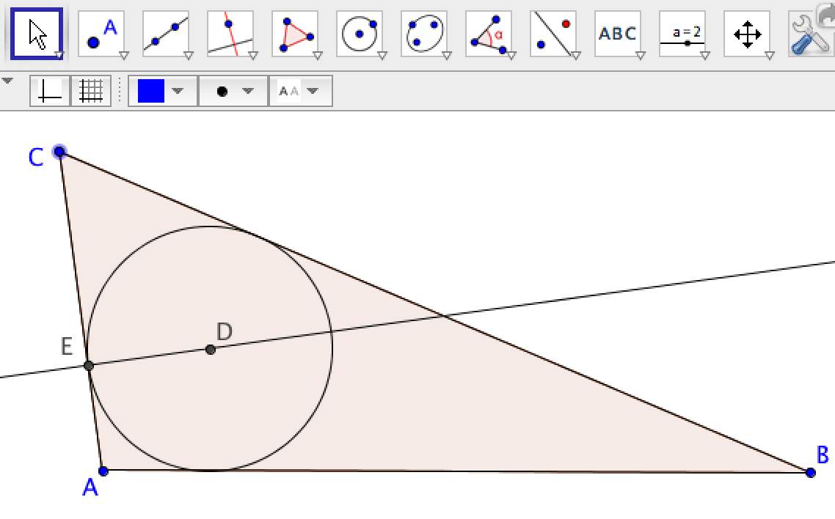
Given triangle ABC, its incenter D has been constructed with a custom tool.

Drag this figure around. Can you see why the five parts of the conjecture should always be true?
Add in the three angle bisectors and the other two perpendiculars through point D. You can change the properties of the perpendicular segments to show the value of their lengths. Drag the figure now. Do the three angle bisectors all meet at the same point? Is that point always inside the triangle? Are the three perpendicular segments between D and the triangle sides all equal? Is the circle through D always inscribed in the triangle? Is it always tangent to the three sides? Can you explain why these relationships are always true? Can you identify dependencies built into the construction that constrain the circle to move so it is always tangent to all three sides?

Construct the Incenter with Standard GeoGebra Tools.
This time, construct the incenter without the custom tool, simply using the standard GeoGebra tools. Construct a simple triangle ABC. Use the angle-bisector tool (pull down from the perpendicular-line tool) to construct the three angle bisectors. They all meet at point D, which is always inside the circle. Now construct perpendiculars from D to the three sides, defining points E, F and G at the intersections with the sides. Segments DE, DF and DG are all the same length. Construct a circle centered on D and passing through E. The circle is tangent at E, F and G. That is the state shown below.
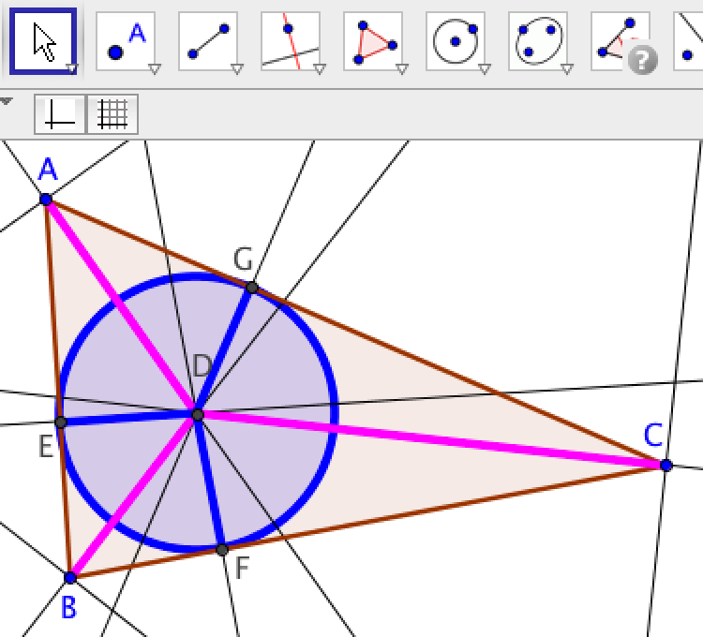
Given a triangle ABC, its incenter has been constructed with the GeoGebra angle-bisector tool.
Drag this figure around. Can you see why the five parts of the conjecture should always be true? Can you identify dependencies built into the construction that constrain the incenter to move in response to movements of A, B or C so that the five parts of the conjecture are always true?

Construct the Incenter with Elementary Line and Circle Tools.
A formal deductive proof of the conjecture would normally start from a completed diagram like the preceding one. Rather than starting from this completed figure, instead proceed through the construction step by step using just elemental straightedge (line) and compass (circle) tools. Avoid using the angle-bisector tool, which hides the dependencies that make the produced line a bisector.
As a first step, construct the angle bisectors of vertex A of a general triangle ABC (see Figure below). Construct the angle bisector by constructing a ray AF that goes from point A through some point F that lies between sides AB and AC and is equidistant from both these sides. This is the dependency that defines an angle bisector: that it is the locus of points equidistant from the two sides of the angle. The constraint that F is the same distance from sides AB and AC is constructed as follows: First construct a circle centered on A and intersecting AB and AC—call the points of intersection D and E. Construct perpendiculars to the sides at these points. The perpendiculars necessarily meet between the sides—call the point of intersection F. Construct ray AF.
AF bisects the angle at vertex A, as can be shown by congruent right triangles ADF and AEF. (Right triangles are congruent if any two sides are congruent because of the Pythagorean relationship, which guarantees that the third sides are also congruent.) This shows that angle BAF equals angle CAF, so that ray AF bisects the vertex angle CAC into two equal angles. By constructing perpendiculars from the angle sides to any point on ray AF, one can show by the corresponding congruent triangles that every point on AF is equidistant from the sides of the triangle.

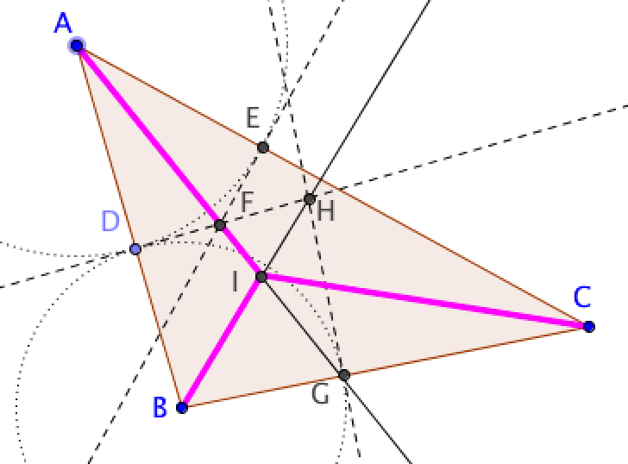
Given a triangle ABC, its incenter has been constructed with basic tools.
As the second step, construct the bisector of the angle at vertex B. First construct a circle centered on B and intersecting side AB at point D—call the circle’s point of intersection with side BC point G. Construct perpendiculars to the sides at these points. The perpendiculars necessarily meet between the sides AB and BC—call the point of intersection H. H has been constructed to lie between AB and BC. Construct ray BH. BH bisects the angle at vertex B, as can be shown by congruent right triangles BDH and BGH, as before.
For the third step, mark the intersection of the two angle-bisector rays AF and BH as point I, the incenter of triangle ABC. Construct segment CI. You can see that CI is the angle bisector of the angle at the third vertex, C in the Figure as follows. Construct perpendiculars IJ, IK, IL from the incenter to the three sides. We know that I is on the bisector of angles A and B, so IJ=IK and IJ=IL. Therefore, IK=IL, which means that I is also on the bisector of angle C. This implies that triangles CKI and CLI are congruent, so that their angles at vertex C are equal and CI bisects angle ACB. You have now shown that point I is common to the three angle bisectors of an arbitrary triangle ABC. In other words, the three angle bisectors meet at one point. The fact that the bisectors of the three angles of a triangle are all concurrent is a direct consequence of the dependencies you imposed when constructing the bisectors.

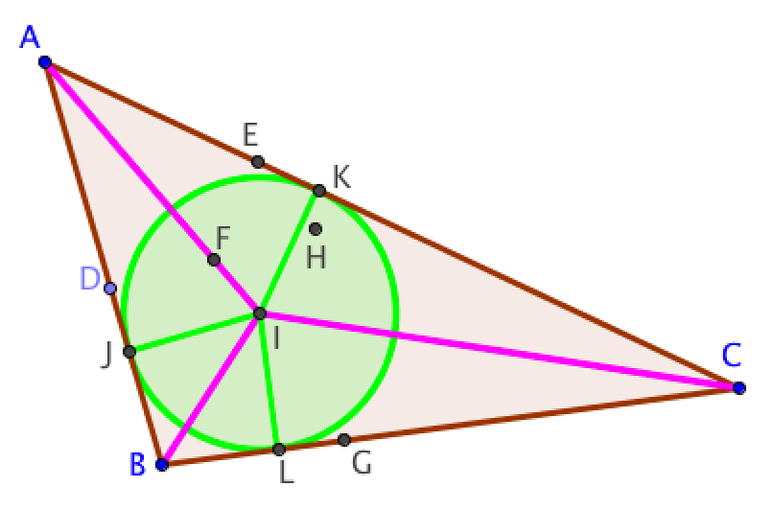
The incenter, I, of triangle ABC, with equal perpendiculars IJ, IK, and IL, which are radii of the inscribed circle.
Now construct a circle centered on the incenter, with radii IJ, IK, and IL. You have already shown that the lengths of IJ, IK and IL are all equal and you constructed them to be perpendicular to the triangle sides. The circle is inscribed in the triangle because it is tangent to each of the sides. (A circle is tangent to a line if its radius to the intersection point is perpendicular to the line.)
Drag the vertex points of the triangle to show that all the discussed relationships are retained dynamically.
Review the description of the construction. Can you see why all of the parts of the conjecture have been built into the dependencies of the figure? None of the parts seem surprising now. They were all built into the figure by the various detailed steps in the construction of the incenter.
When you used the custom incenter tool or even the GeoGebra angle-bisector tool, you could not notice that you were thereby imposing the constraint that DF=EF, etc. It was only by going step-by-step that you could see all the dependencies that were being designed into the figure by construction. The packaging of the detailed construction process in special tools obscured the imposition of dependencies. This is the useful process of “abstraction” in mathematics: While it allows you to build quickly upon past accomplishments, it has the unfortunate unintended consequence of hiding what is taking place in terms of imposing dependencies.
In the Figure where only the elementary “straightedge and compass” tools of the point, line and circle have been used the perpendiculars have been constructed without even using the perpendicular tool. All of the geometric relationships, constraints and dependencies that are at work in the earlier Figures are visible in this one. This construction involved the creation of 63 objects (points, lines and circles). It is becoming visually confusing. That is why it is often useful to package all of this in a special tool, which hides the underlying complexity. It is wonderful to use these powerful tools, as long as you understand what dependencies are still active behind the visible drawing.
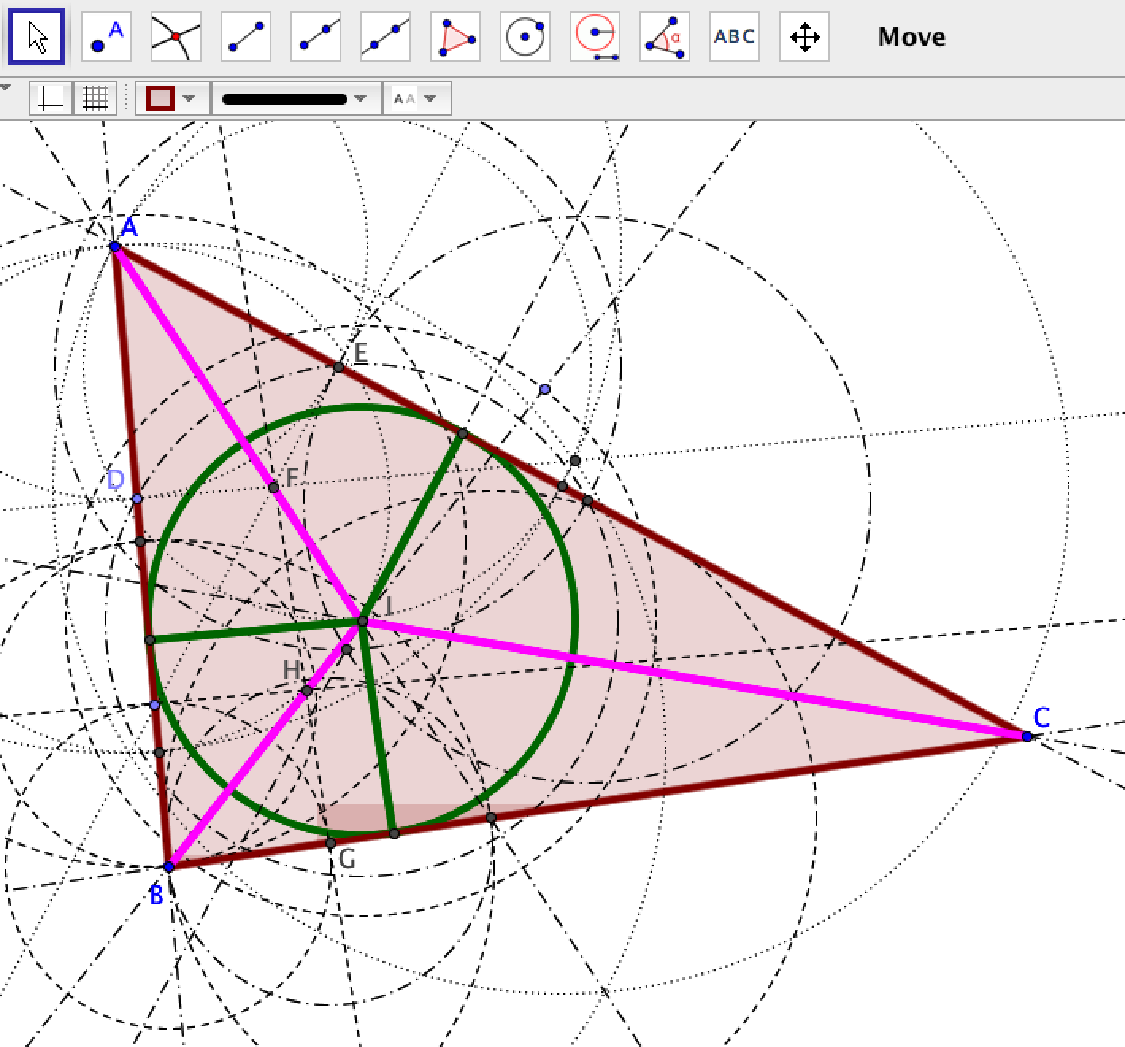
Given a triangle ABC, its incenter has been constructed with only elementary point, line and circle tools.

Your own Custom Geometry
In Challenge 46, you saw how to define your own tools in GeoGebra. You could define a whole set of tools that would form your own version of geometry.

For instance, if you just use GeoGebra’s tools for point, line and circle, you could define your own custom tools, such as:
Given three points A, B and C, construct a triangle ABC.
- Given two points A and B, construct an equilateral triangle on base AB.
- Given a line through A and B, construct a perpendicular bisector of AB.
What is the smallest set of GeoGebra tools you would need to make a set of your own custom tools sufficient for constructing all the Challenges in the Game?

Can you invent an innovative form of mathematics using a set of custom and standard tools? For instance, can you define custom tools to construct people, cars, streets and houses? Then define ways for them to move and interact. A system of mathematics requires a set of building blocks (like integers, points, etc.) and a set of procedures for combining them (like multiplication or construction or translation).

Transforming a Factory
In this topic, you will conduct mathematical studies to help design a widget factory. The movement of polygon-shaped widgets, which the factory processes, can be modeled in terms of rigid transformations of polygons. You will explore physical models and GeoGebra simulations of different kinds of transformations of widgets. You will also compose multiple simple transformations to create transformations that are more complex, but might be more efficient. You will apply what you learned to the purchase of widget-moving machines in a factory.

Designing a Factory
Suppose you are the mathematician on a team of people designing a new factory to process widgets. In the factory, special machines will be used to move heavy widgets from location to location and to align them properly. There are different machines available for moving the widgets. One machine can flip a widget over; one can slide a widget in a straight line, one can rotate a widget. As the mathematician on the team, you are supposed to figure out the most efficient way to move the widgets from location to location and to align them properly. You are also supposed to figure out the least expensive set of machines to do the moving.
The factory will be built on one floor and the widgets that have to be moved are shaped like flat polygons, which can be laid on their top or bottom. Therefore, you can model the movement of widgets as rigid transformations of polygons on a two-dimensional surface. See what you can learn about such transformations.

Experiment with Physical Transformations
To get a feel for this task, take a piece of cardboard and cut out an irregular polygon. This polygon represents a widget being processed at the factory. Imagine it is moved through the factory by a series of machines that flip it, slide it and rotate it to move it from one position to another on the factory floor.
Place the polygon on a piece of graph paper and trace its outline. Mark that as the “start state” of the polygon. Move the cardboard polygon around. Flip it over a number of times. What do you notice? Rotate it around its center or around another point. Slide it along the graph paper. Finally, trace its outline again and mark that as the “end state” of the transformation.
Place the polygon at its start state position. What is the simplest way to move it into its finish state position? What do you notice about different ways of doing this?
Now cut an equilateral triangle out of the cardboard and do the same thing. Is it easier to transform the equilateral triangle from its start state to its finish state than it was for the irregular polygon? What do you notice about flipping the triangle? What do you notice about rotating the triangle? What do you notice about sliding the triangle?
What do you are wonder about transformations of polygons?

Transformational Geometry
In a previous activity with triangles, you saw that there were several kinds of rigid transformations of triangles that preserved the measures of the sides and the angles of the triangles. You also learned about GeoGebra tools that could transform objects in those ways, such as:
- Reflect Object about Line
- Rotate Object around Point by Angle
- Translate Object by Vector
These tools can transform any polygon in these ways and preserve the measures of their sides and angles. In other words, these geometric transformations can model the movement of widgets around the factory.

Composing Multiple Transformations
In addition to these three kinds of simple transformations, you can “compose” two or more of these to create a more complicated movement. For instance, a “glide reflection” could be defined as reflecting an object about a line and then translating the reflected object by a vector. Composing three transformations means taking an object in its start state, transforming it by the first transformation into a second state, then transforming it with the second transformation from its second state into a third state, and finally transforming it with the third transformation from its third state into its end state. You can conceive of this as a single complex transformation from the object’s start state to its end state.
The study of these transformations is called “transformational geometry.” There are some important theorems in transformational geometry. Maybe you can discover some of them and even find some of your own. These theorems can tell you what is possible or optimal in the widget factory’s operation.

An Example of Transformations in GeoGebra

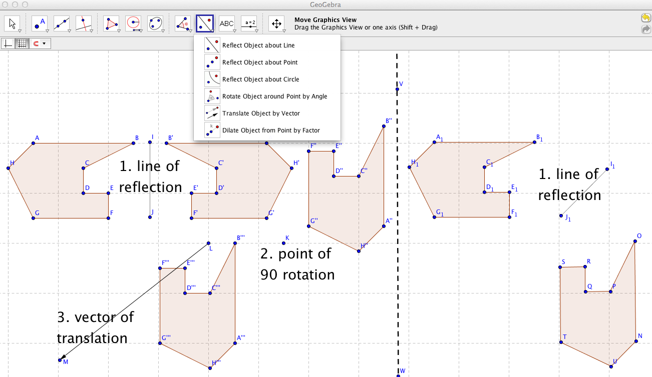

In this figure, an irregular polygon ABCDEFGH has gone through 3 transformations: a reflection (about line IJ), a rotation (about point K), and a translation (by vector LM). A copy of the polygon has gone through just 1 transformation (a reflection about line I₁J₁) and ended in the same relative position and orientation. There are many sequences of different transformations to transform a polygon from a particular starting state (position and orientation) to an end state (position and orientation). Some possible alternative sequences are simpler than others.
Discuss with your group how you want to proceed with each of the following explorations. Do each one together with your group, sharing GeoGebra constructions. Save a construction view for each exploration to include in your summary. Discuss what you are doing, what you notice, what you wonder, how you are constructing and transforming polygons, and what conjectures you are considering.

Exploration 1
Consider the transformations in the previous figure. Drag the line of reflection (line IJ), the point of rotation (point K), the translation vector (vector LM) and the alternative line of reflection (line NO). How does this affect your ability to substitute the one reflection for the sequence on three transformations? What ideas does this give you for the lay-out of work-flow in a factory?

Exploration 2
Consider just simple rotations of an irregular polygon. Suppose you perform a sequence of five or six rotations of the polygon widget around different points. Would it be possible to get from the start state to the end state in a fewer number of rotations? In other words, can the factory be made more efficient?
Consider the same question for translations of widgets.
Consider the same question for reflections of widgets.

Exploration 3
Perhaps instead of having a machine in the factory to flip widgets and a different machine to move the widgets, there should be a machine that does both at the same time. Consider a composite transformation, like a glide reflection composed of a reflection followed by a translation. Suppose you perform a sequence of five or six glide reflections on an irregular polygon. Does it matter what order you perform the glide reflections? Would it be possible to get from the start state to the end state in a fewer number of glide reflections?
Does it matter if a glide reflection does the translation before or after the reflection?
Consider the same questions for glide rotations.

Exploration 4
Factory managers always want to accomplish tasks as efficiently as possible. What is the minimum number of simple transformation actions needed to get from any start state of the irregular polygon in the figure to any end state? For instance, can you accomplish any transformation with three (or fewer) simple actions: one reflection, one rotation and one translation (as in the left side of the preceding figure)? Is it always possible to achieve the transformation with fewer than three simple actions (as in the right side of the figure)?

Exploration 5
Factory managers always want to save costs. If they can just buy one kind of machine instead of three kinds, that could save money. Is it always possible to transform a given polygon from a given start state to a specified end state with just one kind of simple transformation – e.g., just reflections, just rotations or just translations? How about with a certain composition of two simple kinds, such as a rotation composed with a translation or a reflection composed with a rotation?

Exploration 6
Help the factory planners to find the most direct way to transform their widgets. Connect the corresponding vertices of the start state and the end state of a transformed polygon. Find the midpoints of the connecting segments. Do the midpoints line up in a straight line? Under what conditions (what kinds of simple transformations) do the midpoints line up in a straight line? Can you prove why the midpoints line up for some of these conditions?
If you are given the start state and the end state of a transformed polygon, can you calculate a transformation (or a set of transforms) that will achieve this transformation? This is called “reverse engineering” the transformation. Hint: constructing the perpendicular bisectors of the connecting segments between corresponding vertices may help in some conditions (with some kinds of simple transformations).

Exploration 7
Different factories process differently shaped widgets. How would the findings or conjectures from Explorations 1 to 5 be different for a widget which is an equilateral triangle than they were for an irregular polygon? How about for a square or circle? How about for a hexagon? How about for other regular polygons?

Exploration 8
So far, you have only explored rigid transformations – which keep the corresponding angles and sides congruent from the start state to the end state. What if you now add dilation transformations, which keep corresponding angles congruent but change corresponding sides proportionately? Use the Dilate-Object-from-Point-by-Factor tool and compose it with other transformations. How does this affect your findings or conjectures from Explorations 1 to 5? Does it affect your factory design if the widgets produced in the factory can be uniformly stretched or shrunk?

Factory Design
Consider the factory equipment now. Suppose the factory needs machines for three different complicated transformations and the machines have the following costs: a reflector machine $20,000; a rotator machine $10,000; a translator machine $5,000. How many of each machine would you recommend buying for the factory?
What if instead they each cost $10,000?

Summarize
Summarize your trials with the cardboard polygons and your work on each of the explorations in a report on your findings. What did you notice that was interesting or surprising? State your conjectures or theorems. Can you make some recommendations for the design of the factory? If you did not reach a conclusion, what do you think you would have to do to reach one? Do you think you could develop a formal proof for any of your conjectures in these explorations?

Navigating Taxicab Geometry
In this topic, you will explore an invented transformational geometry that has probably never been analyzed before (except by other teams who did this topic). Taxicab geometry is considered a “non-Euclidean” form of geometry, because in taxicab geometry the shortest distance between two points is not necessarily a straight line. Although it was originally considered by the mathematician Minkowski (who helped Einstein figure out the non-Euclidean geometry of the universe), taxicab geometry can be fun for amateurs to explore. Krause (1986) wrote a nice introductory book on it that uses an inquiry approach, mainly posing thought-provoking problems for the reader. Gardner devoted his column on mathematical games in Scientific American to clever extensions of it in November 1980.

An Invented Taxicab Geometry
There is an intriguing form of geometry that is called “taxicab geometry” because all lines, objects and movements are confined to a grid. It is like a grid of streets in a city where all the streets either run north and south or they run east and west. For a taxicab to go from one point to another in the city, the shortest route involves movements along the grid. Taxicab geometry provides a model of urban life and navigation.
In taxicab geometry as we will define it for this topic, all points are at grid intersections, all segments are confined to the grid lines and their lengths are confined to integer multiples of the grid spacing. The only angles that exist are multiples of 90° — like 0°, 90°, 180°, 270° and 360°. Polygons consist of segments connected at right angles to each other.
How would you define the rigid transformations of a polygon in taxicab geometry? Discuss this with your team and decide on definitions of rotation, translation and reflection for this geometry. (See 0 for an example.)
Use GeoGebra with the grid showing. Use the grid icon on the lower toolbar to display the grid; the pull-down menu from the little triangle on the right lets you activate “Snap to Grid” or “Fixed to Grid. The menu “Options” | “Advance” | “Graphics” | “Grid” lets you modify the grid spacing. Only place points on the grid intersections.
Construct several taxicab polygons. Can you use GeoGebra’s transformation tools (rotation, translation and reflection)? Or do you need to define custom transformation tools for taxicab geometry? Or do you have to manually construct the results of taxicab transformations? Rotate (by 90° or 180°), translate (along grid lines to new grid intersections) and reflect (across segments on grid lines) your polygons.

Explore Taxicab Transformational Geometry
Now consider the question that you explored for classical transformational geometry in Challenges 30-34. Can all complex transformations be accomplished by just one kind of transformation, such as reflection on the grid? What is the minimum number of simple transformations required to accomplish any change that can be accomplished by a series of legal taxicab transformations?
In Euclidean geometry, if a right triangle has sides of length 3 and 4, the hypotenuse is 5, forming a right triangle with integer lengths. In taxicab geometry, a right triangle with legs of 3 and 4 seems to have a hypotenuse of 7, which can be drawn along several different paths. In the grid shown below, a 3-4-7 right triangle ABC (green) has been reflected about segment IJ (blue), then translated by vector KL (blue), and then rotated 180° clockwise about point C'' (brown). Equivalently, ABC (green) has been reflected about segment BC (red), then reflected about the segment going down from C'₁ (red), and then reflected about segment A'''M''' (brown). Thus, in this case, the composition of a reflection, a translation and a rotation can be replicated by the composition of just reflections, three of them.

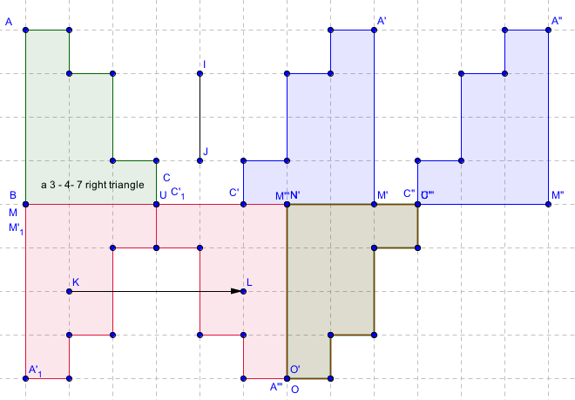

Explore Kinds of Polygons and their Symmetries
What distinct kinds of “polygons” are possible in taxicab geometry? Can you work out the hierarchy of different kinds of “taxicab polygons” with each number of sides? E.g., are there right or equilateral taxicab triangles? Are there square or parallelogram taxicab quadrilaterals?

Discuss and Summarize
What have you or your pod noticed about taxicab transformational geometry? What have you wondered about and investigated? Do you have conjectures? Did you prove any theorems in this new geometry? What questions do you still have?
Be sure to write down your findings, as well as wonderings that you would like to investigate in the future.

Congratulations!
You have now completed the topics in this book. You are ready to explore dynamic geometry and GeoGebra on your own or to propose further investigations for your pod. You can also create GeoGebra resources with your own topics and invite people to work together on them.

following is an academic article that discusses how this game can be a model of curriculum for “blended learning,” which combines teacher-led classroom instruction and student-centered collaborative learning. It was published as: Stahl, G. (2021). Redesigning mathematical curriculum for blended learning. Education Sciences. 11(165), pages 1-12. Web: https://www.mdpi.com/2227-7102/11/4/165.

Redesigning Mathematical Curriculum for Blended Learning
Abstract: The Coronavirus pandemic has thrown public schooling into crisis, trying to juggle shifting instructional modes: classrooms, online, home-schooling, student pods, hybrid and blends of these. This poses an urgent need to redesign curriculum using available technology to implement approaches that incorporate the findings of the learning sciences, including the emphasis on collaborative learning, computer mediation, student discourse and embodied feedback. This paper proposes a model of such learning, illustrated using existing dynamic-geometry technology to translate Euclidean geometry study into collaborative learning by student pods. The technology allows teachers and students to interact with the same material in multiple modes, so that blended approaches can be flexibly adapted to students with diverse preferred learning approaches or needs and structured into parallel or successive phases of blended learning. The technology can be used by online students, co-located small groups and school classrooms, with teachers and students having shared access to materials and to student work across interaction modes.
Keywords: dynamic geometry; group practices; CSCL, group cognition, learning pods.

Introduction: Student Pods during the Pandemic
Alternatives to the traditional teacher-centric physical classroom suddenly became necessary during the coronavirus pandemic to cover a variety of shifting learning options at all age levels. Although the creation of student “pods” (small groups of students who study together) was popularized as a way of restricting the spread of virus, it was rarely transferred to the organization of online learning as collaborative learning.
Research in the learning sciences has long explored pedagogies and technologies for student-centered and collaborative learning (Sawyer, 2021). However, the prevailing practice of schooling has changed little (Sinclair, 2008); students, parents, teachers, school districts and countries were poorly prepared for the challenges of the pandemic. Case studies from countries around the world documented the common perceptions by students, teachers and administrators of inadequate infrastructure and pedagogical preparation for online learning (Noor, Isa & Mazhar, 2020; Peimani & Kamalipour, 2021).
An abrupt rush to online modes found that the digital divide that leaders had promised to address for decades still left disadvantaged populations out (Blume, 2020; Preez & Grange, 2020). Income inequality by class and nation correlates strongly with lack of computer and Internet access. In addition to confronting these hardware issues and low levels of computer training, teachers everywhere had access to few applications designed to support student learning in specific disciplines. They had to rely on commercial business software like Zoom and management systems like Blackboard, which incorporated none of the lessons of learning-sciences research.
While school districts planned for “reopening,” administrators prepared scenarios for combining in-class, online, home schooling and small student pods. The plans kept shifting and little was done to prepare and support teachers to teach in these various combinations of modalities. Moreover, teachers were rarely guided in redesigning their curriculum for online situations, in which they were often neither trained nor experienced.
Pundits and early surveys were quick to call the attempt to teach online a failure and declare that it simply highlighted how important social interaction was to students. They argued that online media severely reduced student motivation by removing inter-personal interaction (Niemi & Kousa, 2020; Tartavulea et al., 2020).
However, the field of computer-supported collaborative learning (CSCL) has always emphasized the centrality of social interaction to learning, demonstrating that sociality could be supported online as well as face-to-face (Cress, Rosé, Wise & Oshima, 2021; Stahl, Koschmann & Suthers, 2021). Micro-analyses of knowledge building in CSCL contexts detail the centrality of social interaction to effective online collaborative learning and even the students’ enjoyment of the online social contact (Stahl, 2021). The source of asocial feelings is the restriction of online education to simply reproducing teacher lectures and repetitive individual drill. It is necessary to explicitly support social contact and interaction among students to replace the subtle student-to-student contact of co-presence. This can be done through collaborative learning, which simultaneously maintains a focus of the interaction on the subject matter.
The pandemic forced teachers to suddenly change their teaching methods and classroom practices, as reported by (Johnson, Veletsianos & Seaman, 2020). The sudden onset of pandemic conditions and school lockdown made it infeasible to introduce new technologies, let alone scale up research prototypes for widespread usage. Nevertheless, the lessons of the pandemic should lead over the longer run to more effective online options, as well as preparation in terms of infrastructure, support, attitude and skills for innovative online educational approaches and applications (Adedoyin & Soykan, 2020).
In the face of the pandemic, teachers and school districts were largely on their own to adapt commercially established technologies like Zoom and Blackboard to changing local circumstances. One innovative example was an attempt to make teacher presentations in Blackboard more interactive by instituting a hybrid audience of some students in class (to provide feedback to the teacher) and others online (Busto, Dumbser & Gaburro, 2021). Other researchers stressed the need to go further and introduce an intermediate scale between the individual students and the teacher-led classroom—namely a student-centered small-group or pod learning unit (Orlov et al., 2020). The following provides an example of how a careful integration of existing technologies (Zoom or Blackboard with GeoGebra) can support pod learning and blend the online with in-class as well as the small group with whole classroom.
This article describes how a research project (Virtual Math Teams, or VMT) translated the ancient pedagogy of Euclidean geometry into a model of CSCL, and how that was then further redesigned to support blended-learning pedagogy for pandemic conditions (with GeoGebra Classes). This can serve as a prototype for the blended teaching of other subjects in mathematics and other fields. If such a model can succeed during the pandemic, it can herald on-going practical new forms of education for the future. The pandemic experience will change schooling to take increased advantage of online communication and offers an opportunity for CSCL to guide that process in a progressive direction. The approach described here using GeoGebra Classes with VMT curriculum can be implemented immediately, during the pandemic, and then further developed later for post-pandemic blended collaborative learning.

Designing for Virtual Math Teams
The VMT research project was conducted at the Math Forum at Drexel University in Philadelphia, USA from 2004 through 2014. The VMT research has been documented in five volumes analyzing excerpts of actual student interaction from a variety of viewpoints and methodologies (Stahl, 2006; 2009; 2013; 2016; 2021).
The project was an extended effort to implement and explore a specific vision of computer-supported collaborative learning (CSCL), applied to the learning of mathematics:
- First, it generated and collected data on small online groups of public-school students collaborating on problem solving.
- Second, it provided computer support, including a shared whiteboard and a dynamic-geometry app.
- Third, it analyzed the group interaction that unfolded in the team discourse.
- Fourth, it elaborated aspects of a theory of “group cognition” (Stahl, 2006). Several papers published during this period and contributing to the broad vision of CSCL have now been reprinted and reflected upon in Theoretical Investigations: Philosophic Foundations of Group Cognition (Stahl, 2021). Several chapters in this volume analyze aspects of group cognition based on excerpts of student discourses during VMT sessions.
The VMT project cycled through many iterations of design-based research (design, trial, analysis, redesign), developing an online collaboration environment for small groups of students to learn mathematics together. The eleven chapters of (Stahl, 2013) describe the project from different perspectives: the CSCL vision; the history, philosophy, nature and mathematics of geometry; the theory of collaboration; the approach to pedagogy, technology and analysis; the curriculum developed; and the design-based character of the research project. The theory of group cognition provides a framework for pod-based education by describing how knowledge building can take place through small-group interaction—with implications for conceptualizing collaborative learning, designing for it, analyzing group-learning processes/practices and assessing its success. The theory explores the inter-weaving of individual, group and classroom learning.
The VMT software eventually incorporated GeoGebra, an app for dynamic geometry, which is freely available and globally popular (available in over a hundred languages). Dynamic geometry is a computer-based version of Euclidean geometry that allows one to construct figures with relationships among the parts and then allows the constructed points to be dragged around to test the dependencies—providing immediate visual feedback (Hölzl, 1996; Jones, 1996; Laborde, 2000).
As part of the VMT Project, curricular units were designed and tried out in online after-school settings (primarily in the Eastern USA), with teacher training on how to guide the student groups and how to integrate and support the online collaborative learning with teacher presentations, readings, homework and class discussion (Grisi-Dicker, Powell, Silverman & Fetter, 2012). The geometry activities provided hands-on experience exploring the basics of dynamic geometry in small-group collaboration. Student peer discussion was encouraged that would promote mathematical discourse and reflection (Sfard, 2008). In this way, the research project translated Euclid’s curriculum into the computer age. Euclid’s Elements (Euclid, 300 BCE), which had inspired thinkers for centuries, was reworked in terms of dynamic geometry and a learning-sciences perspective (Sinclair, 2008).

Redesigning for Pandemic Pods with GeoGebra Classes
The VMT platform was no longer available when the pandemic appeared and made the need for supporting online learning particularly urgent. While teachers and students can download GeoGebra without VMT, that would not support full collaboration, where several students can work together on a shared geometric figure. Fortunately, GeoGebra recently released a “Class” function, in which a teacher can invite several students (a pod) to work on their own versions of the same construction, and the teacher can view each student’s construction work and discussion in a Class dashboard (Figures 1 and 2). The dashboard provides a form of “learning analytics” (Cress et al., 2021) support for the teacher, which can also be adapted to facilitate student collaboration.
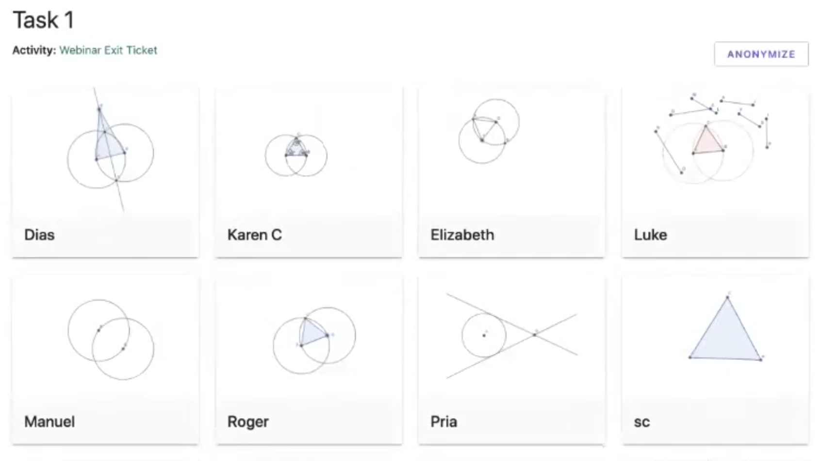
Figure 1. The GeoGebra Class dashboard displays the current state of each student’s work on a selected task. In this example, the students are learning Euclid’s construction of an equilateral triangle.
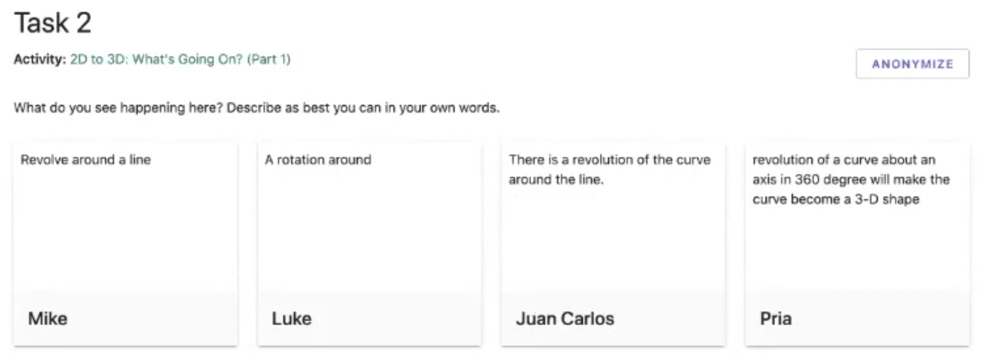
Figure 2. The GeoGebra Class dashboard also displays each student’s response to selected questions. In this example the students are discussing rotating a 2-D curve into the 3rd dimension.
To take advantage of GeoGebra Classes, VMT’s dynamic-geometry curriculum has now been adapted to small pods or even home-schooled individual students using the Classes functionality. The new curriculum is called Dynamic Geometry Game for Pods (Stahl, 2020). Using a set of 50 GeoGebra activities that cover much of basic high-school or college geometry, the instructions and the reflection questions were reworked for the new scenario (Figures 3 and 4). The sequencing of tasks was maintained from VMT, which roughly followed Euclid’s (300 BCE) classic presentation as well as contemporary U.S. Common Core guidelines for geometry courses (National Governors Association Center for Best Practices & Council of Chief State School Officers, 2010).
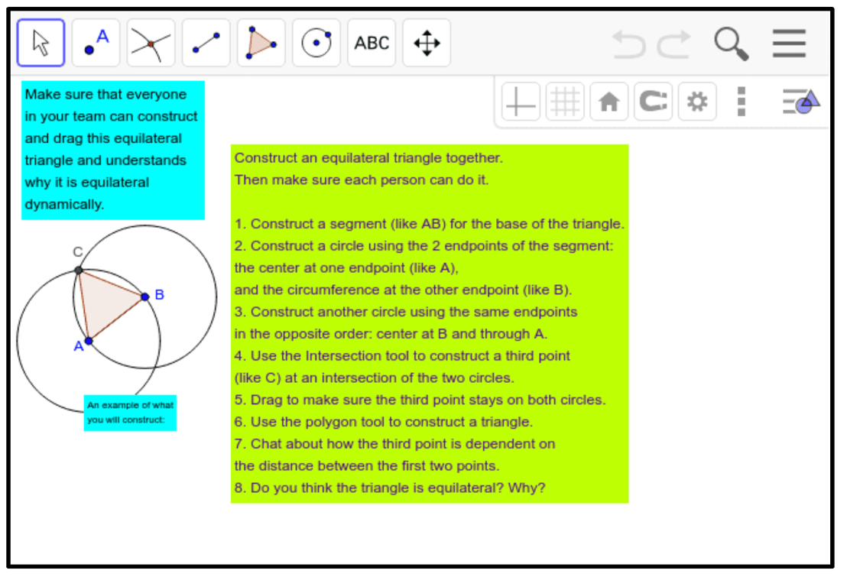
Figure 3. One of 50 tasks for student pods: Euclid’s construction of an equilateral triangle.
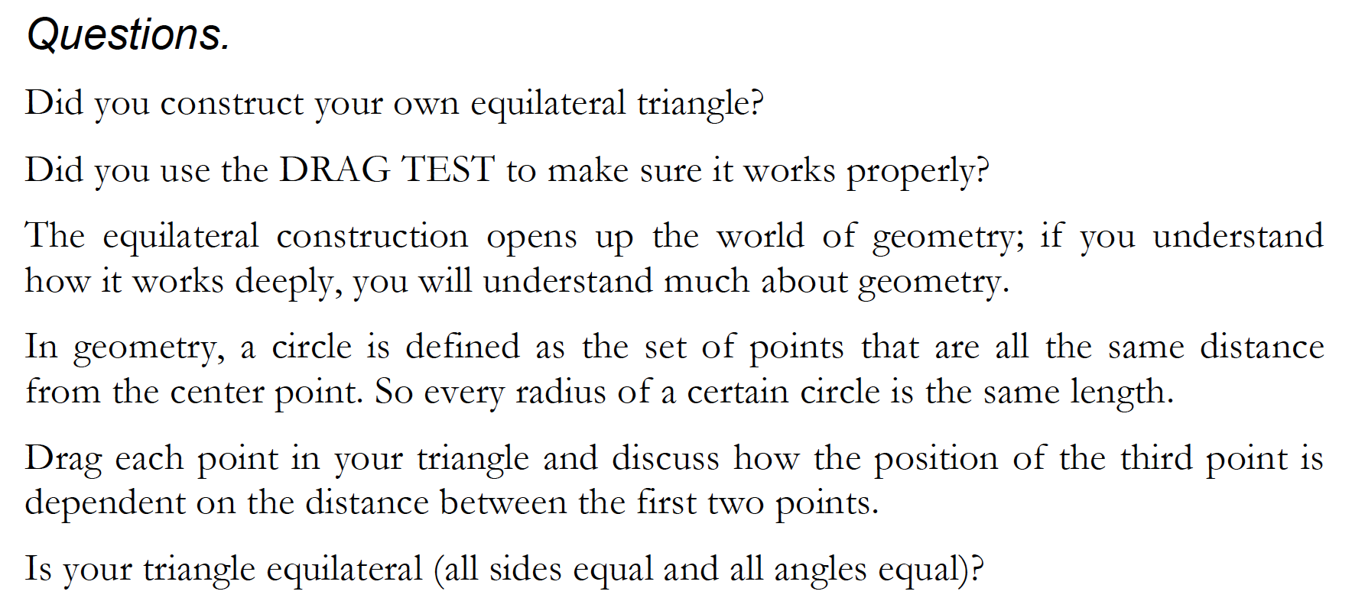
Figure 4. A set of reflection questions for members of pods to discuss related to the task in Figure 3.
The revised curriculum is available on the GeoGebra repository site as an interactive GeoGebra book. Additionally, a free e-book is available so people can conveniently review the curriculum offline (Stahl, 2020). The book’s introductions guide classroom teachers, home-schooling parents, pod tutors or self-guided students to use the curriculum. The format is that of a game with successively challenging levels, which must be conquered consecutively. It is structured as a sequence of five parts, each including about 10 of the hour-long curricular activities, grouped by geometry level and degree of expertise required. The game levels are: (1) beginner, (2) construction, (3) triangles, (4) circles, (5) dependency, (6) compass, (7) congruence, (8) inscribed polygons, (9) transformation, (10) quadrilaterals, (11) advanced geometer, (12) problem solver and (13) expert.
The ideal usage would be by pods of students working online and communicating through the dashboard. A pod coordinator or teacher can provide all participants with access to the real-time dashboard, so that everyone can observe and discuss what everyone else is doing in GeoGebra and typing in the Class interface. Furthermore, GeoGebra can be shared in Zoom, to provide spoken interaction and recording of sessions for student reflection, teacher supervision or researcher analysis.
Note that the Class functionality is not fully collaborative, even when all students have access to the dashboard. Each student works in their own construction area (Figure 1), unlike the shared workspace of the VMT software (Figure 3). Also, each student answers the reflection questions in their own window (Figure 2), rather than in a chat window as in VMT. However, at least the students can see each other’s work and learn from it. Also, if GeoGebra is embedded in Zoom, then the students can discuss their approaches together. The limited support for collaboration is a trade-off of using established software for innovative pedagogy.
The goal is that math teachers and others can adapt the use of this curriculum and technology to diverse and rapidly changing teaching conditions and learning modalities. If used with full online access—including the Class dashboard shared by everyone, possibly embedded in Zoom—the collaborative learning experience can approach that envisioned in the VMT research. However, it can also be used in other ways and across various presentation modalities of blended approaches. Student work carried out individually can be shared within a Class pod and then presented in a whole classroom setting, whether virtual or face-to-face.
The usage of GeoGebra in a collaborative online session can provide all students with hands-on experience in geometry construction and investigation (manipulation and reflection). A major advantage of collaborative learning is that students can help each other, pooling their partially developed skills and understanding. However, it is also important for teachers to provide introductions to new ideas and to review in the classroom context the work that students are doing in pods or individually. Furthermore, individual students must make sense of the material for themselves; reading and working individually on problems is important to support collaborative learning. That is why teachers should orchestrate blended learning, incorporating individual, small group and classroom learning in a coordinated, mutually supportive way. Of course, students learn best in diverse ways, so it is productive to offer them alternative educational modalities. Teachers can adapt and mix the modalities in response to local circumstances and learning differences among their students.

Findings from VMT Trials
The VMT Project was conceived and executed as extended design-based research (DBR), as detailed in (Stahl, 2013). This involved innovations in technology, pedagogy, assessment and theory. Each aspect of the VMT Project has been reviewed in multiple formats and contexts by international researchers from relevant disciplines.
Findings from the project have been discussed in about 250 publications, including peer-reviewed workshops, conference papers, journal articles, dissertations and books. The project evolved over a decade, prototyping and testing technologies and curricula that underwent multiple iterative revisions each year. The current curriculum for blended learning, Dynamic Geometry Game for Pods, is the latest iteration, moving from the VMT software platform to the GeoGebra Class function to support blended learning including collaborative learning in online student pods.
Although a variety of analysis approaches were applied to identify successes and problems during VMT trials, most of the published analyses used a form of conversation analysis adopted from informal conversation to the interaction of online school mathematics. While most of the analyses focused on brief interactions among small groups of students, some included longer sequences, sometimes spanning multiple sessions. For instance, the entire interaction of a group of three middle-school girls—the “Cereal Team”—was followed longitudinally across eight hour-long online sessions and was subjected to detailed micro-analysis of all the discourse and geometry construction (see Stahl, 2013, Chapter 7; 2016).
As suggested by the title of (Stahl, 2013), Translating Euclid: Designing a Human-Centered Mathematics, the pedagogy was converted away from expecting students to accept and memorize concepts, theorems and techniques based on authority. Instead, the project promoted a student-centered and inquiry-based approach of exploration, feedback and discourse based on situated and embodied interaction with computer-based artifacts and guided discussion practicing the use of mathematical terminology.
Although the VMT Project was originally intended to investigate and document phenomena of group cognition (Stahl, 2006), in the end it proposed a methodological focus on group practices (Stahl, 2016). The sequencing of challenges in the Dynamic Geometry Game for Pods is carefully designed to guide student groups and individuals to adopt group practices and individual skills needed to progress through the process of collaboratively learning dynamic geometry. For instance, procedures for placing lines, dragging points, constructing circles and checking connections among objects are practiced before more complex constructions are proposed, which rely on these skills. The VMT research indicates that such an approach can be effective without being overly directive if a group of students can explore and discuss each technique collaboratively. The Dynamic Geometry Game for Pods is based on this body of findings, as well as on the extensive learning-science literature that underlies the VMT project’s theory of group cognition, reviewed in (Stahl, 2021).

Supporting Group Practices in Blended Learning
Teachers, parents and pod organizers can now use the GeoGebra book with its 50 challenges for courses in high-school geometry. Educators in other fields could follow this example and develop analogous curriculum and technology usage. Then the results of such educational interventions could be collected, shared and analyzed. Analysis techniques honed during the VMT Project (Medina & Stahl, 2021) could be used along with other methods to investigate collaboration patterns in interaction discourse, the adoption of targeted group practices and advancement of learning goals.
This approach contrasts with the view of learning as primarily a psychological process of changing an individual’s mental contents or cerebral representations (Gardner, 1985; Thorndike, 1914). Rather, individual learning is seen as largely a result of group and social processes or practices in which multiple people, artifacts, technologies and discourses interact to evolve cognitive products at the group level, such as geometric constructions, informal proofs, group reports and textual responses to questions (Stahl & Hakkarainen, 2021). Such group products require the establishment and maintenance of mutual understandings, intersubjectivity, distributed cognition, communal conceptualizations, common interpretations of problems, collaborative problem solving and shared knowledge. While individuals contribute to these group phenomena, the collective products have a life of their own (Latour, 1996; 2008; Lave & Wenger, 1991; Tomasello, 2014; Vygotsky, 1930; 1934/1986).
One way that group cognition can result in individual learning is through the adoption of group practices, which then provide models for individual behavior (Stahl, 2021, Chapter 16). For instance, a pod of students working on a geometry problem can encounter a concept, theorem or technique that may originate with a pod member, from the problem description or from the history of geometry. The pod discussion may then explicitly discuss what was encountered, come to a shared understanding of how it applies to the pod’s current situation and even overtly agree to use it. In subsequent interactions, the pod simply applies the new practice without discussing it again. It becomes a tacit group practice, recognized by everyone in the pod. Pod members may also retain this practice as their own individual mathematical skill when they work outside the pod.
While the theory of group cognition and group practice has been discussed at length in the reports of the VMT Project, it will be interesting to see how these theories are manifested in new situations in which the Dynamic Geometry Game for Pods or analogous curricula are enacted. In addition to these quite broad theories, the VMT Project developed characteristics that may be more specific to digital geometry. It will be important to investigate the applicability of these features in new contexts and disciplines.
A central focus of the Dynamic Geometry Game for Pods is on the practices involving dependency as central to dynamic-geometric constructions. For instance, in constructing an equilateral triangle with radii of equal circles, it is essential that the lengths of the three sides are dependent upon the equal radii, even when a triangle vertex or a circle center is dragged to a new location. Indeed, the proof that the triangle is equilateral hinges on this dependency—and has for thousands of years since Euclid (300 BCE). Viewing constructions in terms of practices that establish and preserve dependencies (rather than in terms of visual appearance or numeric measurements) is quite difficult for students to learn. One can observe such an insight as it emerges in the discourse of a pod, assuming that the curriculum has been effectively designed to promote such a group practice.
One aspect of curriculum design to support the adoption of specific group practices in dynamic geometry is to sequence tasks and associated practices carefully. This is clear in Euclid’s carefully ordered presentation and in the hierarchies of theorems in every area of mathematics.
However, in collaborative learning of geometry, groups must adopt more practices than just the purely mathematical ones. Specifically, the micro-analysis of the eight sessions of the Cereal Team identified about sixty group practices that the group explicitly, observably enacted. These practices successively contributed to various core aspects of the group’s abilities: to collaborate online; to drag, construct, and transform dynamic-geometry figures; to use GeoGebra tools; to identify and construct geometric dependencies; and to engage in mathematical discourse about their accomplishments.
Table 1 lists practices explicitly discussed by the Cereal Group and identified in the analysis of their discourse (Stahl, 2016). Each of these practices is illustrated in the commentary on the detailed transcript of the student group’s interaction. One can see the group negotiating, adopting and reusing each group practice in the context of their mathematical problem solving and online collaborative learning.

Table 1. Identified practices adopted by the Cereal Group.
Group collaboration practices:
- Discursive turn taking (responding to each other and eliciting responses).
- Coordinating activity (deciding who should take each step).
- Constituting a collectivity (e.g., using “we” rather than “I” as agent).
- Sequentiality (establishing meaning by temporal context).
- Co-presence (being situated together in a shared world of concerns).
- Joint attention (focus on the same, shared images, words and actions).
- Opening and closing topics (changing discourse topics together).
- Interpersonal temporality (recognizing the same sequence of topics, etc.).
- Shared understanding (common ground).
- Repair of understanding problems (explicitly fixing misunderstandings).
- Indexicality (referencing the same things with their discourse).
- Use of new terminology (adopting new shared words).
- Group agency (deciding what to do as a group).
- Sociality (maintaining friendly relations).
- Intersubjectivity (sharing perspectives).
Group dragging practices:
- Do not drag lines to visually coincide with existing points, but use the points to construct lines between or through them.
- Observe visible feedback from the software to guide dragging and construction.
- Drag points to test if geometric relationships are maintained.
- Drag geometric objects to observe invariances.
- Drag geometric objects to vary the figures and see if relationships are always maintained.
- Some points cannot be dragged or only dragged to a limited extent; they are constrained.
Group construction practices:
- Reproduce a figure by following instruction steps.
- Draw a figure by dragging objects to appear right.
- Draw a figure by dragging objects and then measure to check.
- Draw a figure by dragging objects to align with a standard.
- Construct equal lengths using radii of circles.
- Use previous construction practices to solve new problems.
- Construct an object using existing points to define the object by those points.
- Discuss geometric relationships as results of the construction process.
- Check a construction by dragging its points to test if relationships remain invariant.
Group tool-usage practices:
- Use two points to define a line or segment.
- Use special GeoGebra tools to construct perpendicular lines.
- Use custom tools to reproduce constructed figures.
- Use the drag test to check constructions for invariants resulting from custom tools.
Group dependency-related practices:
- Drag the vertices of a figure to explore its invariants and their dependencies.
- Construct an equilateral triangle with two sides having lengths dependent on the length of the base, by using circles to define the dependency.
- Circles that define dependencies can be hidden from view, but not deleted, and still maintain the dependencies.
- Construct a point confined to a segment by creating a point on the segment.
- Construct dependencies by identifying relationships among objects, such as segments that must be the same length.
- Construct an inscribed triangle using the compass tool to make distances to the three vertices dependent on each other.
- Use the drag test to check constructions for invariants.
- Discuss relationships among a figure’s objects to identify the need for construction of dependencies.
- Points in GeoGebra are colored differently if they are free, restricted or dependent.
- Indications of dependency imply the existence of constructions (such as regular circles or compass circles) that maintain the dependencies, even if the construction objects are hidden.
- Construct a square with two perpendiculars to the base with lengths dependent on the length of the base.
- Construct an inscribed square using the compass tool to make distances on the four sides dependent on each other.
- Use the drag test routinely to check constructions for invariants.
Group practices using chat and GeoGebra actions:
- Identify a specific figure for analysis.
- Reference a geometric object by the letters labeling its vertices or defining points.
- Vary a figure to expand the generality of observations to a range of variations
- Drag vertices to explore what relationships are invariant when objects are moved, rotated, extended.
- Drag vertices to explore what objects are dependent upon the positions of other objects.
- Notice interesting behaviors of mathematical objects
- Use precise mathematical terminology to describe objects and their behaviors.
- Discuss observations, conjectures and proposals to clarify and examine them.
- Discuss the design of dependencies needed to construct figures with specific invariants.
- Use discourse to focus joint attention and to point to visual details.
- Bridge to past related experiences and situate them in the present context.
- Wonder, conjecture, propose. Use these to guide exploration.
- Display geometric relationships by dragging to reveal and communicate complex behaviors.
- Design a sequence of construction steps that would result in desired dependencies.
- Drag to test conjectures.
- Construct a designed figure to test the design of dependencies.

The design of curriculum for collaborative or blended learning can be motivated by the goal of promoting the adoption of specific group practices. The curriculum can, for instance, scaffold collaboration practices like turn taking to get all students in a group involved. Then it can support discourse practices to help groups make their meanings explicit and shared.
Some of the listed group practices are specific to the collaborative learning of dynamic geometry with GeoGebra. Many are generally supportive of productive collaborative interaction and discourse. Each subject area will have its own central practices to be supported and mastered, as well as the more universal ones. It is instructive to see the special demands of dynamic geometry. In addition to the focus on construction of dependencies and the associated discourse of how different elements of a figure are dependent upon each other, the use of GeoGebra introduces further specific challenges. For instance, it was necessary to design the VMT technology to allow all group members to observe each other’s construction sequences in detail as they unfolded in real time in the app, because the animation of those processes could be quite informative (Çakir, Zemel & Stahl, 2009). In addition, the immediate feedback afforded by GeoGebra—for instance when someone dragged a point and the whole construction changed, revealing what was and what was not dependent on that point—was crucial for group behavior, discourse and learning.

Broadening the Model for Blended Learning
The proposed use of GeoGebra Classes illustrates the adaption of existing technology to an educational innovation explored in research using a prototype that is not available for widespread use during the pandemic. While the GeoGebra Classes functionality does not fully support small groups to share a workspace for exploring geometric construction, it does provide an available platform for student pods working within a teacher-led classroom. Students in a pod can see each other’s work in real time and can reflect upon it by answering questions that are integrated into the curriculum. The teacher can also follow all the student work and discourse and display this within a classroom context. Thus, blended learning is supported with online GeoGebra, individual construction and reflection, small-group interaction and classroom presentation and discussion. The latest version of the online VMT curriculum is fully incorporated in a motivational game-challenge format. Optionally, the GeoGebra Class can be embedded in Zoom or Blackboard to support additional online and blended functionality.
The research that lies behind the VMT curriculum resulted in enumeration of group practices that are important to support for collaborative learning in its subject domain of dynamic geometry. Research reports developed the theory of group cognition, which describes how small groups can build knowledge collaboratively, in orchestration with individual learning and classroom instruction. They analyzed in considerable detail the nature of online mathematical discourse and problem solving, including how to support and analyze it.
These features of the VMT experience will need to be reconsidered in the design and analysis of support for blended learning in other subject areas, particularly to the extent that curriculum and technology diverge from dynamic geometry and GeoGebra. Just as the VMT project focused its curriculum on geometric dependencies as central to mastering dynamic geometry, efforts in other disciplines may target concepts that underlie their subjects, much as Roschelle’s (1996) early CSCL physics support app targeted the understanding of acceleration as core to learning Newtonian mechanics or an algebra curriculum might revolve around the preservation of equalities.
Dynamic geometry is just one area of mathematics covered by GeoGebra. The software supports all of school mathematics from kindergarten through junior college. It is available in over a hundred world languages. Thus, a teacher, parent or student who masters dynamic geometry through the curriculum discussed here can go on to explore other areas of mathematics with this kind of computer support. Learning scientists can develop curriculum units for all ages in all countries following the model illustrated here by the Dynamic Geometry Game for Pods.
This is not to say that all instruction should be provided in a CSCL format. Collaboration can be particularly productive for exploring problems that are somewhat beyond the reach of individual students. Also, small-group collaborative learning is most effective in sessions that are orchestrated into sequences of individual, group and classroom activities that support each other (Dillenbourg, Nussbaum, Dimitriadis & Roschelle, 2013; Stein, Engle, Smith & Hughes, 2008). Blended learning approaches can supplement collaborative learning with complementary instructional modes. For example, a teacher presentation and student readings can precede online peer interaction, which is followed up by classroom discussion and reporting. While teachers struggle to find effective approaches in flipped, hybrid and online classes, there is now a clear opportunity for moving CSCL ideas into widespread practice. Exploration of pod-based learning during the pandemic could lead to important innovations in post-pandemic blended, collaborative and online learning.
It is difficult to convert courses from in-class to online. Typically, much of the effort goes into designing the curriculum and student tasks in advance and instituting new procedures and expectations for the students. A culture of collaboration must be established in the classroom over time. For instance, grading should be redefined in terms of group participation and team accomplishments. It takes several iterations to work things out; in each course, it requires teacher patience while students adjust. Students must be guided to communicate with their collaborators and to let go of competitive instincts.
The model proposed here is not a panacea for the current crisis of schooling, but rather an indication of a potential direction forward, for the remainder of the pandemic and beyond. We need to overcome the digital divide, promote collaborative learning, develop educational technology for exploring many domains, train teachers in online teaching, redesign curriculum to make it flexible for shifting modes of schooling. If we do not do this, then the learning sciences will have missed an opportunity to promote new forms of collaborative, inquiry-based and computer-supported learning. Only by meeting this challenge can we avoid the looming destruction of public education and the resultant serious worsening of social inequity.

References
Adedoyin, O. B., & Soykan, E. (2020). Covid-19 pandemic and online learning: The challenges and opportunities, interactive learning environments. Interactive Learning Environments.
Blume, C. (2020). German teachers’ digital habitus and their pandemic pedagogy. Postdigital Science and Education. 2, 879–905.
Busto, S., Dumbser, M., & Gaburro, E. (2021). A simple but efficient concept of blended teaching of mathematics for engineering students during the covid-19 pandemic. Educ. Sci., 11(56).
Çakir, M. P., Zemel, A., & Stahl, G. (2009). The joint organization of interaction within a multimodal CSCL medium. International Journal of Computer-Supported Collaborative Learning. 4(2), 115-149. Web: http://ijcscl.org/?go=contents.
Cress, U., Rosé, C., Wise, A., & Oshima, J. (Eds.). (2021). International handbook of computer-supported collaborative learning. New York, NY: Springer.
Dillenbourg, P., Nussbaum, M., Dimitriadis, Y., & Roschelle, J. (2013). Design for classroom orchestration. Computer Education. 69, 485-492.
Euclid. (300 BCE). Euclid's elements (T. L. Heath, Trans.). Santa Fe, NM: Green Lion Press.
Gardner, H. (1985). The mind's new science: A history of the cognitive revolution. New York, NY: Basic Books.
Grisi-Dicker, L., Powell, A. B., Silverman, J., & Fetter, A. (2012). Addressing transitional challenges to teaching with dynamic geometry in a collaborative online environment. In L. R. V. Zoest, J.-J. Lo & J. L. Kratky (Eds.), Proceedings of the 34th annual meeting of the north American chapter of the international group for the psychology of mathematics education. (pp. 1024-1027). Kalamazoo, Michigan: Western Michigan University.
Hölzl, R. (1996). How does “dragging” affect the learning of geometry. International Journal of Computers for Mathematical Learning. 1(2), 169–187.
Johnson, N., Veletsianos, G., & Seaman, J. (2020). U.S. Faculty and administrators’ experiences and approaches in the early weeks of the covid-19 pandemic. Online Learning. 24(2), 6-21.
Jones, K. (1996). Coming to know about ‘dependency’ within a dynamic geometry environment. In the proceedings of the 20th Conference of the International Group for the Psychology of Mathematics Education. L. P. a. A. Gutiérrez. University of Valencia. Proceedings pp. 3: 145-152.
Laborde, C. (2000). Dynamic geometry environments as a source of rich learning contexts for the complex activity of proving. Educational Studies in Mathematics. 44, 151–161.
Latour, B. (1996). On interobjectivity. Mind, Culture and Activity. 3(4), 228-245.
Latour, B. (2008). The Netz-works of Greek deductions. Social Studies of Science. 38(3), 441-459.
Lave, J., & Wenger, E. (1991). Situated learning: Legitimate peripheral participation. Cambridge, UK: Cambridge University Press.
Medina, R., & Stahl, G. (2021). Analysis of group practices. In U. Cress, C. Rosé, A. Wise & J. Oshima (Eds.), International handbook of computer-supported collaborative learning. New York, NY: Springer. Web: http://GerryStahl.net/pub/gpanalysis.pdf.
National Governors Association Center for Best Practices, & Council of Chief State School Officers. (2010). Common core state standards for mathematics. Washington, DC: National Governors Association Center for Best Practices, Council of Chief State School Officers. Web: http://www.corestandards.org.
Niemi, H. M., & Kousa, P. (2020). A case study of students’ and teachers’ perceptions in a finnish high school during the covid pandemic. International Journal of Technology in Education and Science (IJTES). 4(4), 352-369.
Noor, S., Isa, F. M., & Mazhar, F. F. (2020). Online teaching practices during the covid-19 pandemic. Educational Process: International Journal. 9(3), 169-184.
Orlov, G., McKee, D., Berry, J., Boyle, A., DiCiccio, T., Ransom, T., et al. (2020). Learning during the covid-19 pandemic: It is not who you teach, but how you teach. Nber working paper no. 28022. Unpublished manuscript. Web: http://www.nber.org/papers/w28022.
Peimani, N., & Kamalipour, H. (2021). Online education and the covid-19 outbreak: A case study of online teaching during lockdown. Educ. Sci., 11(72).
Preez, P. d., & Grange, L. l. (2020). The covid-19 pandemic, online teaching/ learning, the digital divide, and epistemological access. Unpublished manuscript. Web: alternation.ukzn.ac.za/Files/books/series-01/01/06-Du-Preez.pdf.
Roschelle, J. (1996). Learning by collaborating: Convergent conceptual change. In T. Koschmann (Ed.), CSCL: Theory and practice of an emerging paradigm. (pp. 209-248). Hillsdale, NJ: Lawrence Erlbaum Associates.
Sawyer, R. K. (Ed.). (2021). Cambridge handbook of the learning sciences. (3rd ed.). Cambridge, UK: Cambridge University Press.
Sfard, A. (2008). Thinking as communicating: Human development, the growth of discourses and mathematizing. Cambridge, UK: Cambridge University Press.
Sinclair, N. (2008). The history of the geometry curriculum in the United States. Charlotte, NC: Information Age Publishing, Inc.
Stahl, G. (2006). Group cognition: Computer support for building collaborative knowledge. Cambridge, MA: MIT Press. Web: http://GerryStahl.net/elibrary/gc.
Stahl, G. (2009). Studying virtual math teams. New York, NY: Springer. Web: http://GerryStahl.net/elibrary/svmt.
Stahl, G. (2013). Translating Euclid: Designing a human-centered mathematics. San Rafael, CA: Morgan & Claypool Publishers. Web: http://GerryStahl.net/elibrary/euclid.
Stahl, G. (2016). Constructing dynamic triangles together: The development of mathematical group cognition. Cambridge, UK: Cambridge University Press. Web: http://GerryStahl.net/elibrary/analysis.
Stahl, G. (2020). Dynamic geometry game for pods. Chatham, MA: Gerry Stahl at Lulu. Web: http://GerryStahl.net/elibrary/game/game.pdf.
Stahl, G. (2021). Theoretical investigations: Philosophical foundations of group cognition. New York, NY: Springer. Web: http://GerryStahl.net/elibrary/investigations.
Stahl, G., & Hakkarainen, K. (2021). Theories of CSCL. In U. Cress, C. Rosé, A. Wise & J. Oshima (Eds.), International handbook of computer-supported collaborative learning. New York, NY: Springer. Web: http://GerryStahl.net/pub/cscltheories.pdf.
Stahl, G., Koschmann, T., & Suthers, D. (2021). Computer-supported collaborative learning. In R. K. Sawyer (Ed.), Cambridge handbook of the learning sciences, third edition. (ch. 21). Cambridge, UK: Cambridge University Press. Web: http://GerryStahl.net/pub/chls3.pdf.
Stein, M. K., Engle, R. A., Smith, M. S., & Hughes, E. K. (2008). Orchestrating productive mathematical discussions: Five practices for helping teachers move beyond show and tell. Mathematical Thinking and Learning. 10(4), 313-340.
Tartavulea, C. V., Albu, C. N., Albu, N., Dieaconescu, R. I., & Petre, S. (2020). Online teaching practices and the effectiveness of the educational process in the wake of the covid-19 pandemic. Amfiteatru Economic. 22(55), 920-936.
Thorndike, E. L. (1914). Educational psychology (Vol. I-III). New York, NY: Teachers College.
Tomasello, M. (2014). A natural history of human thinking. Cambridge: MA: Harvard University Press.
Vygotsky, L. (1930). Mind in society. Cambridge, MA: Harvard University Press.
Vygotsky, L. (1934/1986). Thought and language. Cambridge, MA: MIT Press.

Notes

Type your reflections on the game and this book here…

This book contains adventures in digital geometry for the minds of students in pods and in home-schooling. Learning about geometry has inspired many of the most important thinkers for centuries and helped them to make sense of the world. This sequence of 50 hands-on challenges will step learners through the most exciting experiences of geometry, from basic points, lines and circles to construction and proof. The book is structured as a game: a series of thought-provoking challenges that provides a stimulating experience of collaboration with pod-mates and a fun introduction to geometry.

https://www.geogebra.org
https://www.geogebra.org/m/vhuepxvq#material/swj6vqbp.

